Figure 6
Connections over 200 kbps in at Least One Direction 2017-2021
(in thousands)

 | 2017 |  | 2018 |  | 2019 |  | 2020 |  | 2021
Technology | Jun | Dec | Jun | Dec | Jun | Dec | Jun | Dec | Jun
Total | 408,692 | 420,838 | 428,864 | 451,062 | 459,327 | 466,302 | 480,185 | 490,888 | 500,261
Total Fixed | 106,130 | 108,065 | 109,087 | 110,784 | 112,725 | 114,291 | 118,449 | 121,250 | 123,425
Mobile Wireless | 302,562 | 312,773 | 319,776 | 340,278 | 346,603 | 352,012 | 361,737 | 369,638 | 376,835

Some previously-published data may have been revised. Numbers may not sum to totals due to rounding.
Source: FCC Form 477.

Figure 7
Residential Connections over 200 kbps in at Least One Direction 2017-2021
(in thousands)

 | 2017 |  | 2018 |  | 2019 |  | 2020 |  | 2021
Technology | Jun | Dec | Jun | Dec | Jun | Dec | Jun | Dec | Jun
Total | 341,094 | 351,966 | 358,867 | 378,286 | 383,605 | 388,344 | 403,212 | 407,652 | 415,260
Total Fixed | 97,071 | 98,845 | 99,758 | 101,348 | 103,118 | 104,703 | 108,909 | 111,621 | 113,581
Mobile Wireless | 244,022 | 253,121 | 259,109 | 276,938 | 280,486 | 283,641 | 294,303 | 296,031 | 301,679

Some previously-published data may have been revised. Numbers may not sum to totals due to rounding.
Source: FCC Form 477.

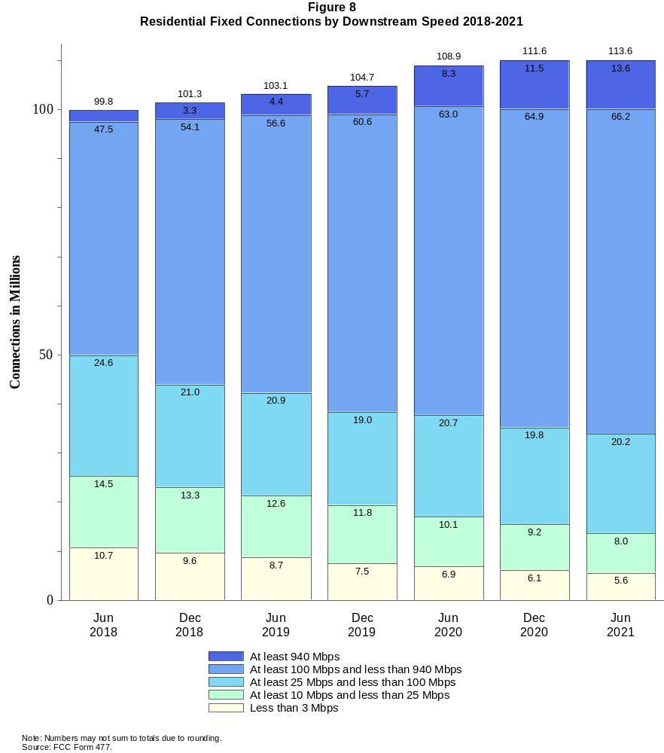

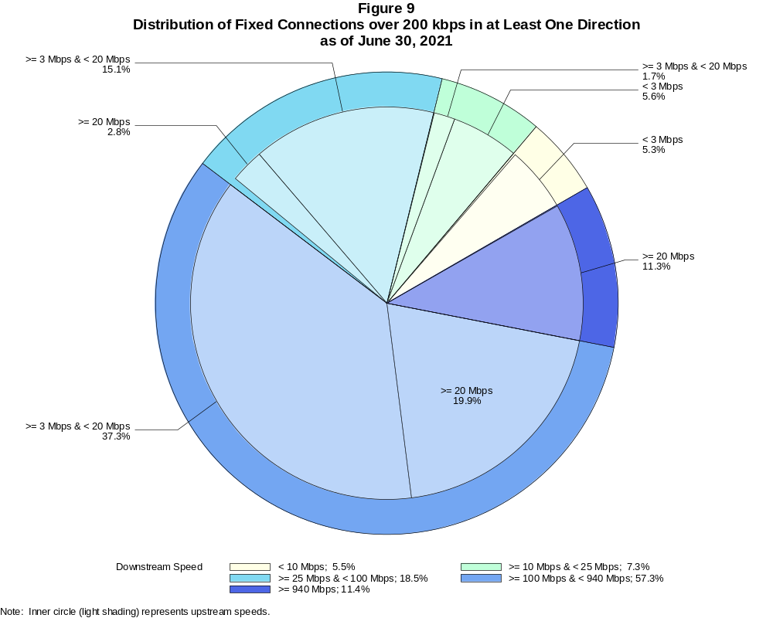

Fixed Connections over 200 kbps in at Least One Direction (in thousands)

 | Downstream Speed
Upstream Speed | Less than 10 Mbps | At least 10 Mbps  and less than 25 Mbps | At least 25 Mbps  and less than 100 Mbps | At least 100 Mbps  and less than 940 Mbps | At least 940 Mbps | Total
Less than 3 Mbps | 6,578 | 6,857 | 784 | 11 | # | 14,229
At least 3 Mbps & Less than 20 Mbps | 211 | 2,122 | 18,647 | 46,083 | 90 | 67,152
At least 20 Mbps | 5 | 65 | 3,412 | 24,593 | 13,970 | 42,044
Total | 6,793 | 9,043 | 22,842 | 70,687 | 14,061 | 123,425

Percentages

Less than 3 Mbps | 5.3 | 5.6 | 0.6 | 0.0 | 0.0 | 11.5
At least 3 Mbps & Less than 20 Mbps | 0.2 | 1.7 | 15.1 | 37.3 | 0.1 | 54.4
At least 20 Mbps | 0.0 | 0.1 | 2.8 | 19.9 | 11.3 | 34.1
Total | 5.5 | 7.3 | 18.5 | 57.3 | 11.4 | 100.0
Note: Numbers may not sum to totals due to rounding. # = Rounds to zero.
Source: FCC Form 477.

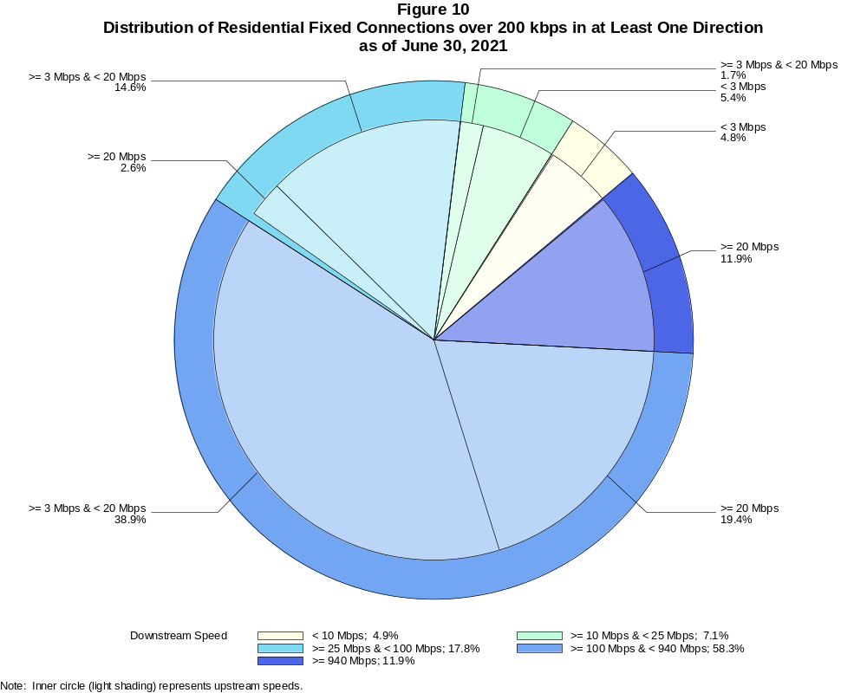

Residential Fixed Connections over 200 kbps in at Least One Direction (in thousands)

 | Downstream Speed
Upstream Speed | Less than 10 Mbps | At least 10 Mbps  and less than 25 Mbps | At least 25 Mbps  and less than 100 Mbps | At least 100 Mbps  and less than 940 Mbps | At least 940 Mbps | Total
Less than 3 Mbps | 5,445 | 6,106 | 722 | 11 | # | 12,284
At least 3 Mbps & Less than 20 Mbps | 123 | 1,894 | 16,552 | 44,215 | 88 | 62,870
At least 20 Mbps | 3 | 24 | 2,944 | 21,989 | 13,467 | 38,427
Total | 5,571 | 8,024 | 20,218 | 66,215 | 13,554 | 113,581

Percentages

Less than 3 Mbps | 4.8 | 5.4 | 0.6 | 0.0 | 0.0 | 10.8
At least 3 Mbps & Less than 20 Mbps | 0.1 | 1.7 | 14.6 | 38.9 | 0.1 | 55.4
At least 20 Mbps | 0.0 | 0.0 | 2.6 | 19.4 | 11.9 | 33.8
Total | 4.9 | 7.1 | 17.8 | 58.3 | 11.9 | 100.0
Note: Numbers may not sum to totals due to rounding. # = Rounds to zero.
Source: FCC Form 477.

Figure 11
Connections over 200 kbps in at Least One Direction by Technology 2017-2021
(in thousands)

 | 2017 |  | 2018 |  | 2019 |  | 2020 |  | 2021
Technology | Jun | Dec | Jun | Dec | Jun | Dec | Jun | Dec | Jun
Total | 408,692 | 420,838 | 428,864 | 451,062 | 459,327 | 466,302 | 480,185 | 490,888 | 500,261
Total Fixed | 106,130 | 108,065 | 109,087 | 110,784 | 112,725 | 114,291 | 118,449 | 121,250 | 123,425
aDSL | 25,505 | 24,193 | 23,074 | 22,377 | 21,163 | 20,214 | 19,639 | 18,786 | 18,085
sDSL | 44 | 28 | 28 | 20 | 17 | 16 | 19 | 13 | 18
Other Wireline¹ | 619 | 581 | 558 | 557 | 501 | 525 | 516 | 527 | 517
Cable Modem | 64,060 | 66,196 | 67,165 | 68,882 | 70,750 | 72,516 | 75,986 | 77,909 | 79,330
FTTP² | 12,831 | 13,890 | 14,889 | 15,492 | 16,748 | 17,376 | 18,443 | 19,945 | 21,120
Satellite | 1,826 | 1,872 | 1,939 | 1,971 | 1,984 | 1,975 | 1,993 | 1,931 | 1,910
Fixed Wireless | 1,245 | 1,306 | 1,434 | 1,485 | 1,561 | 1,669 | 1,853 | 2,140 | 2,445
Mobile Wireless | 302,562 | 312,773 | 319,776 | 340,278 | 346,603 | 352,012 | 361,737 | 369,638 | 376,835

¹ Power Line and Other are summarized with Other Wireline for confidentiality reasons. See Technical Notes at the end of the report for a description of
FCC Form 477 technology categories and other reporting requirements.
² Fiber to the premises.
Note: Some previously-published data may have been revised. Numbers may not sum to totals due to rounding.
Source: FCC Form 477.

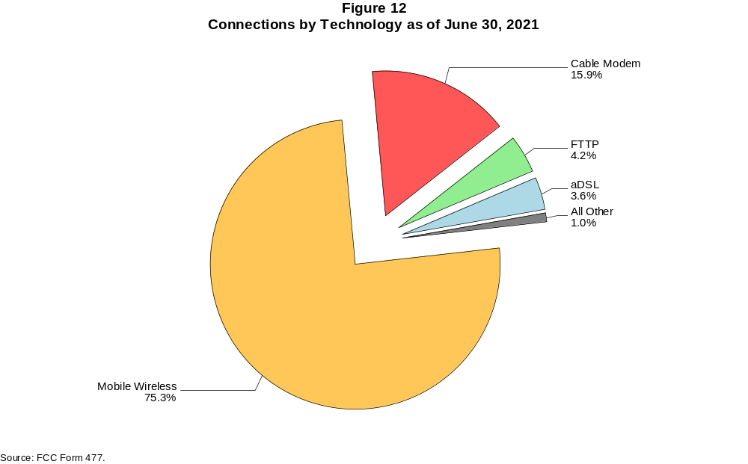

Figure 13
Residential Connections over 200 kbps in at Least One Direction by Technology 2017-2021
(in thousands)

 | 2017 |  | 2018 |  | 2019 |  | 2020 |  | 2021
Technology | Jun | Dec | Jun | Dec | Jun | Dec | Jun | Dec | Jun
Total | 341,094 | 351,966 | 358,867 | 378,286 | 383,605 | 388,344 | 403,212 | 407,652 | 415,260
Total Fixed | 97,071 | 98,845 | 99,758 | 101,348 | 103,118 | 104,703 | 108,909 | 111,621 | 113,581
aDSL | 22,774 | 21,653 | 20,671 | 20,126 | 18,976 | 18,159 | 17,647 | 16,920 | 16,278
sDSL | 12 | 9 | 9 | 4 | 4 | 5 | 7 | 3 | 4
Other Wireline¹ | 74 | 67 | 74 | 76 | 62 | 74 | 64 | 59 | 63
Cable Modem | 59,687 | 61,567 | 62,320 | 63,813 | 65,457 | 67,141 | 70,710 | 72,543 | 73,844
FTTP² | 11,776 | 12,702 | 13,663 | 14,205 | 15,410 | 16,011 | 16,971 | 18,384 | 19,414
Satellite | 1,637 | 1,688 | 1,751 | 1,787 | 1,805 | 1,795 | 1,815 | 1,752 | 1,728
Fixed Wireless | 1,112 | 1,158 | 1,270 | 1,338 | 1,405 | 1,520 | 1,694 | 1,958 | 2,251
Mobile Wireless | 244,022 | 253,121 | 259,109 | 276,938 | 280,486 | 283,641 | 294,303 | 296,031 | 301,679

¹ Power Line and Other are summarized with Other Wireline for confidentiality reasons. See Technical Notes at the end of the report for a description of
FCC Form 477 technology categories and other reporting requirements.
² Fiber to the premises.
Note: Some previously-published data may have been revised. Numbers may not sum to totals due to rounding.
Source: FCC Form 477.

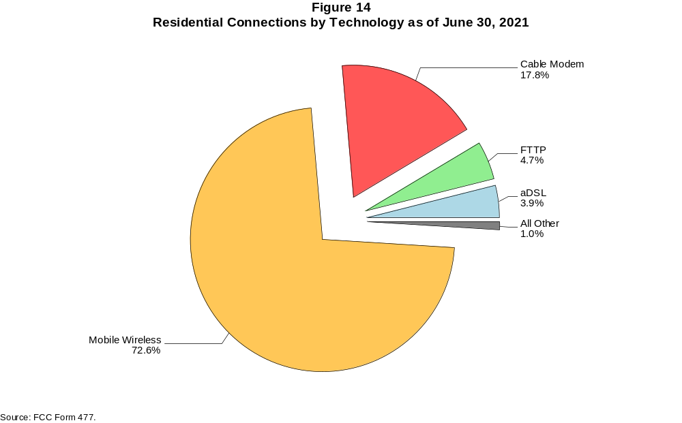

Figure 15
Fixed Connections at Least 10 Mbps Downstream and 1 Mbps Upstream by Technology 2017-2021
(in thousands)

 | 2017 |  | 2018 |  | 2019 |  | 2020 |  | 2021
Technology | Jun | Dec | Jun | Dec | Jun | Dec | Jun | Dec | Jun
Total | 86,886 | 90,609 | 94,071 | 97,302 | 100,464 | 103,595 | 109,159 | 112,445 | 115,772
aDSL | 11,321 | 11,598 | 11,822 | 12,038 | 11,829 | 11,704 | 12,421 | 11,760 | 12,017
sDSL | 14 | 9 | 11 | 6 | 5 | 5 | 8 | 4 | 7
Other Wireline¹ | 246 | 262 | 271 | 292 | 261 | 301 | 307 | 323 | 323
Cable Modem | 61,704 | 63,978 | 65,808 | 67,716 | 69,704 | 71,934 | 75,391 | 77,513 | 79,035
FTTP² | 11,811 | 12,869 | 13,898 | 14,815 | 16,078 | 16,854 | 17,993 | 19,555 | 20,813
Satellite | 1,373 | 1,402 | 1,595 | 1,677 | 1,726 | 1,737 | 1,778 | 1,727 | 1,717
Fixed Wireless | 418 | 491 | 666 | 759 | 861 | 1,059 | 1,263 | 1,564 | 1,860

¹ Power Line and Other are summarized with Other Wireline for confidentiality reasons. See Technical Notes at the end of the report for a description of
FCC Form 477 technology categories and other reporting requirements.
² Fiber to the premises.
# = Rounds to zero.
Note: Some previously-published data may have been revised. Numbers may not sum to totals due to rounding.
Source: FCC Form 477.

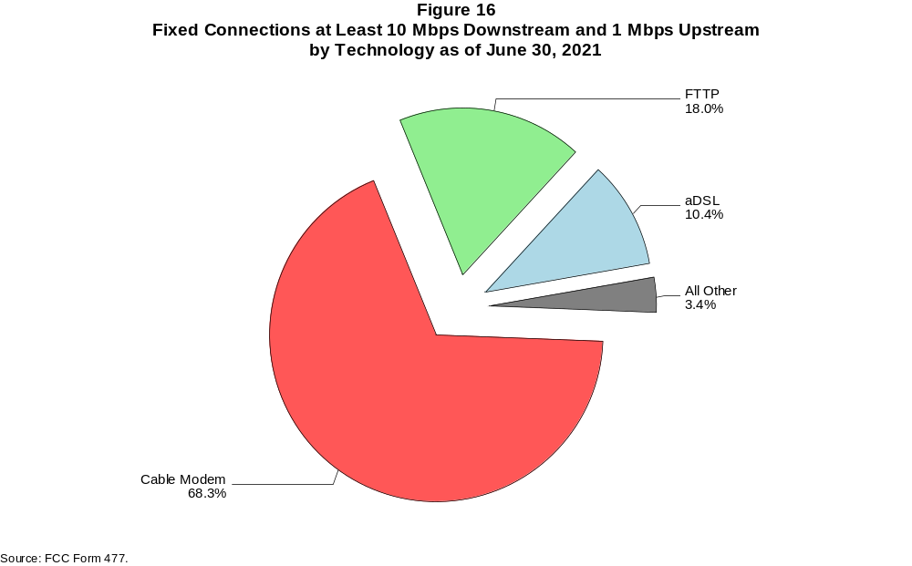

Figure 17
Residential Fixed Connections at Least 10 Mbps Downstream and 1 Mbps Upstream by Technology 2017-2021
(in thousands)

 | 2017 |  | 2018 |  | 2019 |  | 2020 |  | 2021
Technology | Jun | Dec | Jun | Dec | Jun | Dec | Jun | Dec | Jun
Total | 80,671 | 84,163 | 86,973 | 89,873 | 92,698 | 95,649 | 101,201 | 104,199 | 107,212
aDSL | 10,415 | 10,657 | 10,862 | 11,073 | 10,812 | 10,682 | 11,374 | 10,761 | 11,003
sDSL | 6 | 5 | 6 | 2 | 1 | 2 | 4 | 1 | 2
Other Wireline¹ | 71 | 64 | 65 | 68 | 58 | 70 | 61 | 56 | 61
Cable Modem | 57,617 | 59,864 | 61,142 | 62,810 | 64,556 | 66,691 | 70,299 | 72,215 | 73,611
FTTP² | 10,835 | 11,762 | 12,741 | 13,589 | 14,800 | 15,536 | 16,566 | 18,042 | 19,145
Satellite | 1,362 | 1,387 | 1,575 | 1,655 | 1,702 | 1,708 | 1,745 | 1,691 | 1,676
Fixed Wireless | 365 | 425 | 582 | 676 | 768 | 960 | 1,151 | 1,433 | 1,714

¹ Power Line and Other are summarized with Other Wireline for confidentiality reasons. See Technical Notes at the end of the report for a description of
FCC Form 477 technology categories and other reporting requirements.
² Fiber to the premises.
# = Rounds to zero.
Note: Some previously-published data may have been revised. Numbers may not sum to totals due to rounding.
Source: FCC Form 477.

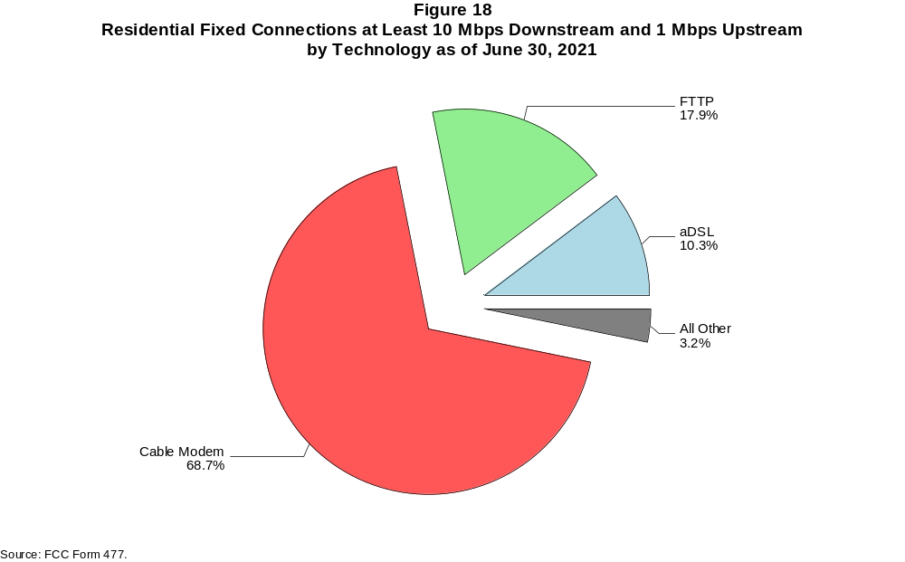

Figure 19
Fixed Connections at Least 25 Mbps Downstream and 3 Mbps Upstream by Technology 2017-2021
(in thousands)

 | 2017 |  | 2018 |  | 2019 |  | 2020 |  | 2021
Technology | Jun | Dec | Jun | Dec | Jun | Dec | Jun | Dec | Jun
Total | 68,280 | 73,875 | 78,952 | 82,965 | 86,744 | 90,471 | 96,984 | 101,630 | 106,794
aDSL | 2,530 | 3,586 | 4,298 | 4,988 | 5,233 | 5,523 | 5,910 | 6,237 | 6,397
sDSL | * | * | * | * | * | * | * | * | 2
Other Wireline¹ | 203 | 219 | 203 | 228 | 220 | 263 | 273 | 286 | 288
Cable Modem | 54,829 | 57,870 | 60,859 | 62,880 | 64,938 | 67,171 | 71,856 | 74,169 | 77,502
FTTP² | 10,344 | 11,489 | 12,568 | 13,605 | 14,902 | 15,866 | 17,076 | 18,840 | 20,171
Satellite | * | * | * | * | * | * | * | * | 1,328
Fixed Wireless | 120 | 143 | 224 | 267 | 325 | 449 | 571 | 804 | 1,105

¹ Power Line and Other are summarized with Other Wireline for confidentiality reasons. See Technical Notes at the end of the report for a description of
FCC Form 477 technology categories and other reporting requirements.
² Fiber to the premises.
* = Data withheld for confidentiality reasons.
# = Rounds to zero.
Note: Some previously-published data may have been revised. Numbers may not sum to totals due to rounding.
Source: FCC Form 477.

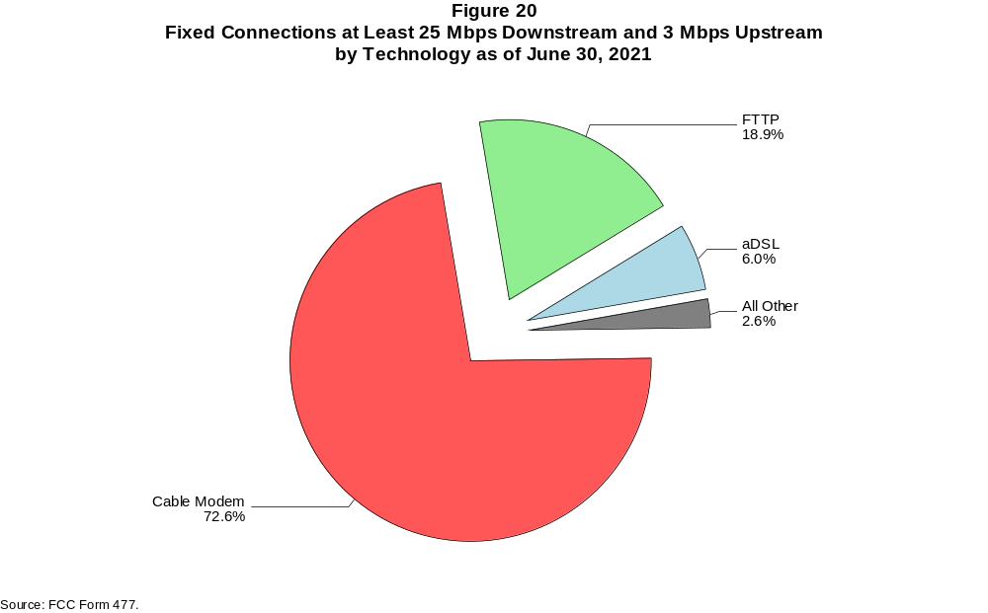

Figure 21
Residential Fixed Connections at Least 25 Mbps Downstream and 3 Mbps Upstream by Technology 2017-2021
(in thousands)

 | 2017 |  | 2018 |  | 2019 |  | 2020 |  | 2021
Technology | Jun | Dec | Jun | Dec | Jun | Dec | Jun | Dec | Jun
Total | 64,520 | 69,447 | 73,288 | 76,873 | 80,256 | 83,725 | 90,170 | 94,451 | 99,254
aDSL | 2,418 | 3,410 | 4,068 | 4,712 | 4,911 | 5,168 | 5,538 | 5,871 | 6,008
sDSL | * | * | * | * | * | * | * | * | 1
Other Wireline¹ | 67 | 59 | 54 | 61 | 53 | 64 | 56 | 51 | 58
Cable Modem | 52,154 | 54,748 | 56,620 | 58,342 | 60,125 | 62,231 | 67,017 | 69,098 | 72,268
FTTP² | 9,532 | 10,553 | 11,570 | 12,546 | 13,780 | 14,690 | 15,781 | 17,445 | 18,615
Satellite | * | * | * | * | * | * | * | * | 1,288
Fixed Wireless | 101 | 119 | 193 | 234 | 283 | 400 | 512 | 727 | 1,015

¹ Power Line and Other are summarized with Other Wireline for confidentiality reasons. See Technical Notes at the end of the report for a description of
FCC Form 477 technology categories and other reporting requirements.
² Fiber to the premises.
* = Data withheld for confidentiality reasons.
# = Rounds to zero.
Note: Some previously-published data may have been revised. Numbers may not sum to totals due to rounding.
Source: FCC Form 477.

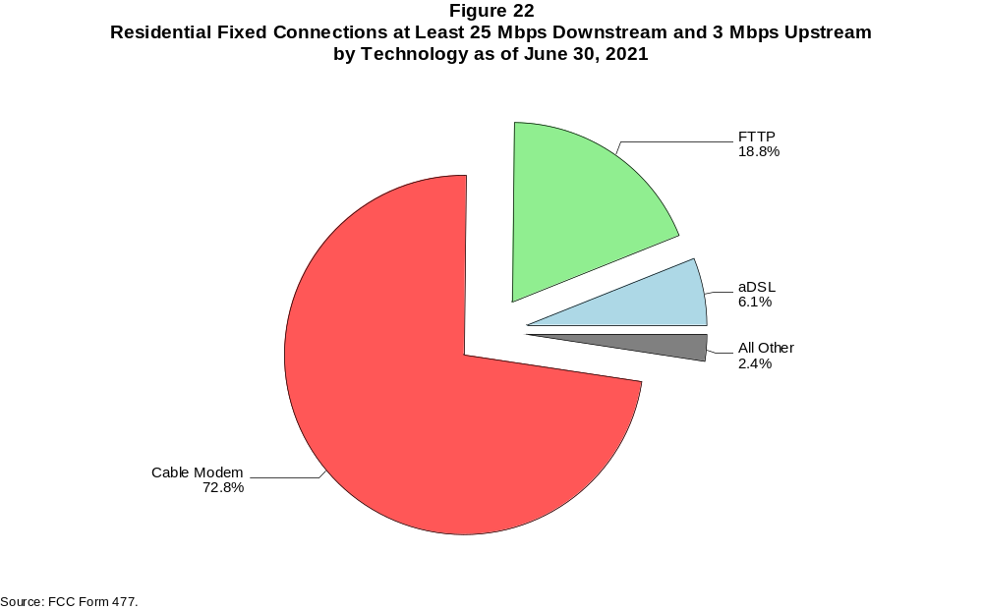

Figure 23
Fixed Connections at Least 100 Mbps Downstream and 20 Mbps Upstream by Technology 2017-2021
(in thousands)

 | 2017 |  | 2018 |  | 2019 |  | 2020 |  | 2021
Technology | Jun | Dec | Jun | Dec | Jun | Dec | Jun | Dec | Jun
Total | 9,676 | 12,148 | 14,619 | 18,750 | 22,217 | 25,603 | 29,554 | 34,493 | 38,563
aDSL | 16 | 47 | 59 | 207 | 387 | 569 | 658 | 774 | 867
sDSL | 1 | 1 | 1 | 1 | # | * | * | * | *
Other Wireline¹ | 174 | 192 | 174 | 196 | 178 | 211 | 213 | 217 | 218
Cable Modem | 6,055 | 7,149 | 8,352 | 9,466 | 11,426 | 13,088 | 15,496 | 18,420 | 20,924
FTTP² | 3,403 | 4,729 | 5,976 | 8,815 | 10,146 | 11,634 | 13,071 | 14,933 | 16,373
Satellite | 0 | 0 | 0 | 0 | 0 | * | * | * | *
Fixed Wireless | 28 | 30 | 56 | 65 | 79 | 101 | 116 | 143 | 180

¹ Power Line and Other are summarized with Other Wireline for confidentiality reasons. See Technical Notes at the end of the report for a description of
FCC Form 477 technology categories and other reporting requirements.
² Fiber to the premises.
* = Data withheld for confidentiality reasons.
# = Rounds to zero.
Note: Some previously-published data may have been revised. Numbers may not sum to totals due to rounding.
Source: FCC Form 477.

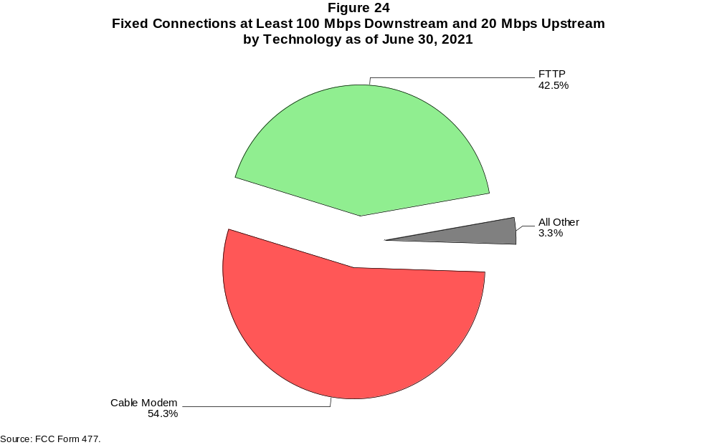

Figure 25
Residential Fixed Connections at Least 100 Mbps Downstream and 20 Mbps Upstream by Technology 2017-2021
(in thousands)

 | 2017 |  | 2018 |  | 2019 |  | 2020 |  | 2021
Technology | Jun | Dec | Jun | Dec | Jun | Dec | Jun | Dec | Jun
Total | 8,879 | 11,030 | 13,171 | 17,101 | 20,322 | 23,469 | 27,164 | 31,773 | 35,456
aDSL | 15 | 42 | 53 | 194 | 344 | 512 | 594 | 733 | 820
sDSL | # | # | # | # | # | * | * | * | *
Other Wireline¹ | 61 | 53 | 46 | 47 | 27 | 36 | 27 | 20 | 21
Cable Modem | 5,695 | 6,591 | 7,491 | 8,512 | 10,312 | 11,883 | 14,157 | 16,843 | 19,128
FTTP² | 3,089 | 4,324 | 5,534 | 8,292 | 9,574 | 10,952 | 12,288 | 14,055 | 15,329
Satellite | 0 | 0 | 0 | 0 | 0 | * | * | * | *
Fixed Wireless | 20 | 20 | 47 | 56 | 65 | 86 | 98 | 118 | 158

¹ Power Line and Other are summarized with Other Wireline for confidentiality reasons. See Technical Notes at the end of the report for a description of
FCC Form 477 technology categories and other reporting requirements.
² Fiber to the premises.
* = Data withheld for confidentiality reasons.
# = Rounds to zero.
Note: Some previously-published data may have been revised. Numbers may not sum to totals due to rounding.
Source: FCC Form 477.

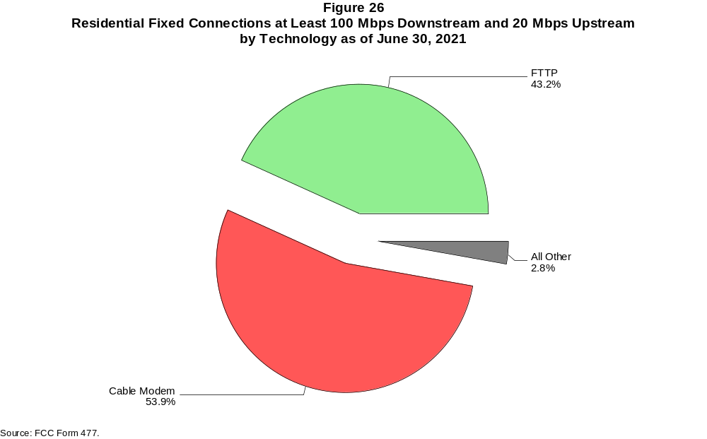

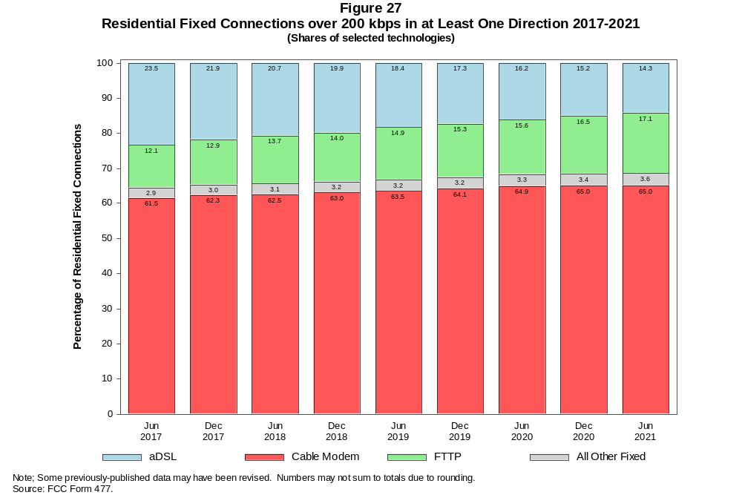

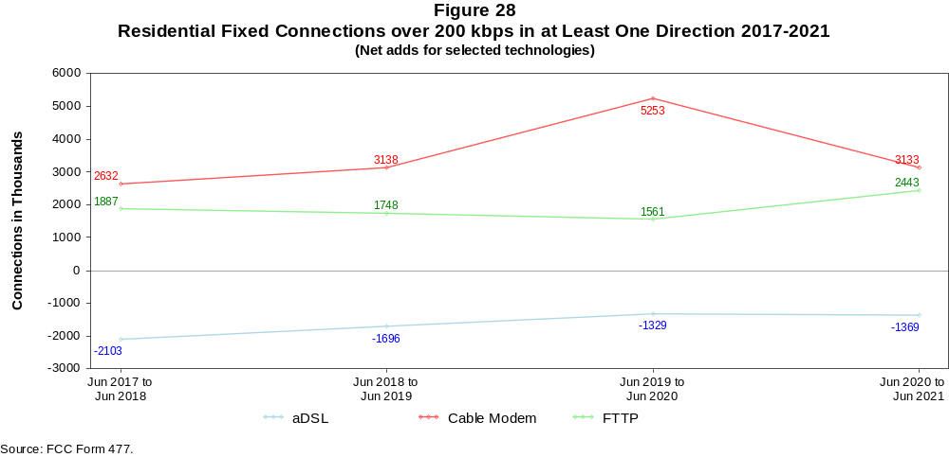

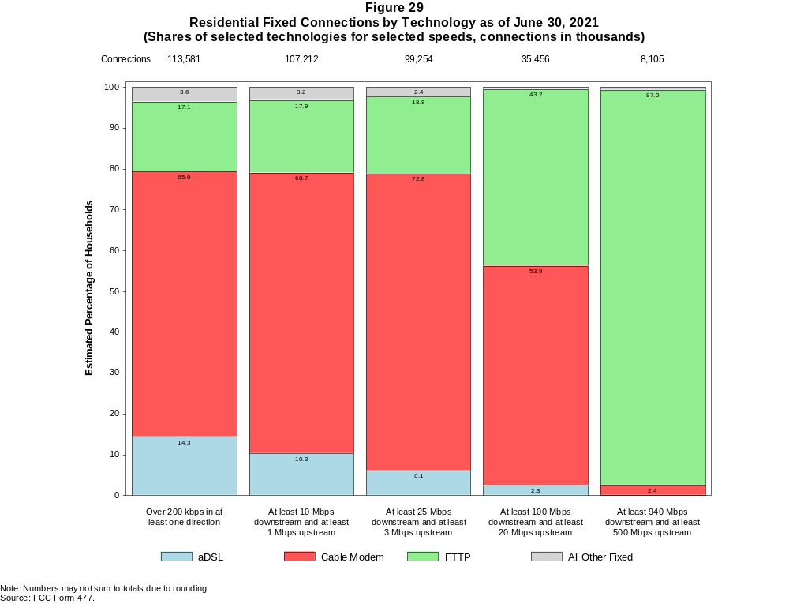

Figure 30
Fixed Connections by Downstream Speed Tier and Technology as of June 30, 2021
(in thousands)

 | Downstream Speed
Technology | Less than  4 Mbps | At least 4 Mbps  and less than  10 Mbps | At least 10 Mbps  and less than  25 Mbps | At least 25 Mbps  and less than  100 Mbps | At least 100 Mbps  and less than  940 Mbps | At least 940 Mbps | Total
aDSL | 2,246 | 2,980 | 5,886 | 5,894 | 1,079 | # | 18,085
sDSL | * | 2 | * | * | * | * | 18
Other Wireline¹ | 164 | 31 | 31 | 42 | 223 | 27 | 517
Cable Modem | 171 | 116 | 1,376 | 11,277 | 60,721 | 5,670 | 79,330
FTTP | 98 | 199 | 610 | 3,458 | 8,442 | 8,314 | 21,120
Satellite | * | 36 | * | * | * | 0 | 1,910
Fixed Wireless | 213 | 372 | 746 | 919 | 145 | 51 | 2,445
Total | 3,059 | 3,735 | 9,043 | 22,842 | 70,687 | 14,061 | 123,425

Percentages

aDSL | 1.8 | 2.4 | 4.8 | 4.8 | 0.9 | 0.0 | 14.7
sDSL | * | 0.0 | * | * | * | * | 0.0
Other Wireline¹ | 0.1 | 0.0 | 0.0 | 0.0 | 0.2 | 0.0 | 0.4
Cable Modem | 0.1 | 0.1 | 1.1 | 9.1 | 49.2 | 4.6 | 64.3
FTTP | 0.1 | 0.2 | 0.5 | 2.8 | 6.8 | 6.7 | 17.1
Satellite | * | 0.0 | * | * | * | 0.0 | 1.5
Fixed Wireless | 0.2 | 0.3 | 0.6 | 0.7 | 0.1 | 0.0 | 2.0
Total | 2.5 | 3.0 | 7.3 | 18.5 | 57.3 | 11.4 | 100.0

¹ Power Line and Other are summarized with Other Wireline for confidentiality reasons. See Technical Notes at the end of the report for a description of FCC Form 477 technology categories
and other reporting requirements.
# = Rounds to Zero.
* = Data withheld for confidentiality reasons.
Note: Numbers may not sum to totals due to rounding.
Source: FCC Form 477.

Figure 31
Residential Fixed Connections by Downstream Speed Tier and Technology as of June 30, 2021
(in thousands)

 | Downstream Speed
Technology | Less than  4 Mbps | At least 4 Mbps  and less than  10 Mbps | At least 10 Mbps  and less than  25 Mbps | At least 25 Mbps  and less than  100 Mbps | At least 100 Mbps  and less than  940 Mbps | At least 940 Mbps | Total
aDSL | 1,882 | 2,611 | 5,249 | 5,519 | 1,017 | # | 16,278
sDSL | * | # | * | * | * | * | 4
Other Wireline¹ | 1 | 1 | 3 | 6 | 29 | 23 | 63
Cable Modem | 150 | 75 | 1,193 | 9,643 | 57,305 | 5,479 | 73,844
FTTP | 81 | 179 | 500 | 2,984 | 7,660 | 8,009 | 19,414
Satellite | * | * | * | * | * | 0 | 1,728
Fixed Wireless | 190 | 347 | 690 | 852 | 128 | 43 | 2,251
Total | 2,324 | 3,247 | 8,024 | 20,218 | 66,215 | 13,554 | 113,581

Percentages

aDSL | 1.7 | 2.3 | 4.6 | 4.9 | 0.9 | 0.0 | 14.3
sDSL | * | 0.0 | * | * | * | * | 0.0
Other Wireline¹ | 0.0 | 0.0 | 0.0 | 0.0 | 0.0 | 0.0 | 0.1
Cable Modem | 0.1 | 0.1 | 1.1 | 8.5 | 50.5 | 4.8 | 65.0
FTTP | 0.1 | 0.2 | 0.4 | 2.6 | 6.7 | 7.1 | 17.1
Satellite | * | * | * | * | * | 0.0 | 1.5
Fixed Wireless | 0.2 | 0.3 | 0.6 | 0.8 | 0.1 | 0.0 | 2.0
Total | 2.0 | 2.9 | 7.1 | 17.8 | 58.3 | 11.9 | 100.0

¹ Power Line and Other are summarized with Other Wireline for confidentiality reasons. See Technical Notes at the end of the report for a description of FCC Form 477 technology categories
and other reporting requirements.
# = Rounds to Zero.
* = Data withheld for confidentiality reasons.
Note: Numbers may not sum to totals due to rounding.
Source: FCC Form 477.

Figure 32
Nationwide Number of Providers of Connections over 200 kbps in at Least One Direction
by Technology 2017-2021

 | 2017 |  | 2018 |  | 2019 |  | 2020 |  | 2021
Technology | Jun | Dec | Jun | Dec | Jun | Dec | Jun | Dec | Jun
aDSL | 768 | 743 | 738 | 721 | 715 | 691 | 677 | 653 | 638
sDSL | 161 | 150 | 136 | 127 | 123 | 121 | 118 | 106 | 102
Other Wireline¹ | 243 | 235 | 249 | 243 | 222 | 211 | 215 | 209 | 203
Cable Modem | 384 | 383 | 372 | 381 | 381 | 373 | 365 | 368 | 362
FTTP | 1,103 | 1,147 | 1,183 | 1,269 | 1,309 | 1,330 | 1,377 | 1,441 | 1,477
Satellite | 5 | 6 | 6 | 6 | 6 | 5 | 5 | 6 | 6
Fixed Wireless | 1,095 | 1,160 | 1,188 | 1,239 | 1,248 | 1,280 | 1,312 | 1,396 | 1,383
Mobile Wireless | 98 | 83 | 73 | 71 | 70 | 67 | 64 | 64 | 63
Total | 2,030 | 2,090 | 2,129 | 2,215 | 2,223 | 2,247 | 2,279 | 2,381 | 2,392

¹ Power Line and Other are summarized with Other Wireline for confidentiality reasons.
Note: Multiple FCC Form 477 filers within a holding company structure count as one provider. Some previously-published data may have been revised.
Source: FCC Form 477.

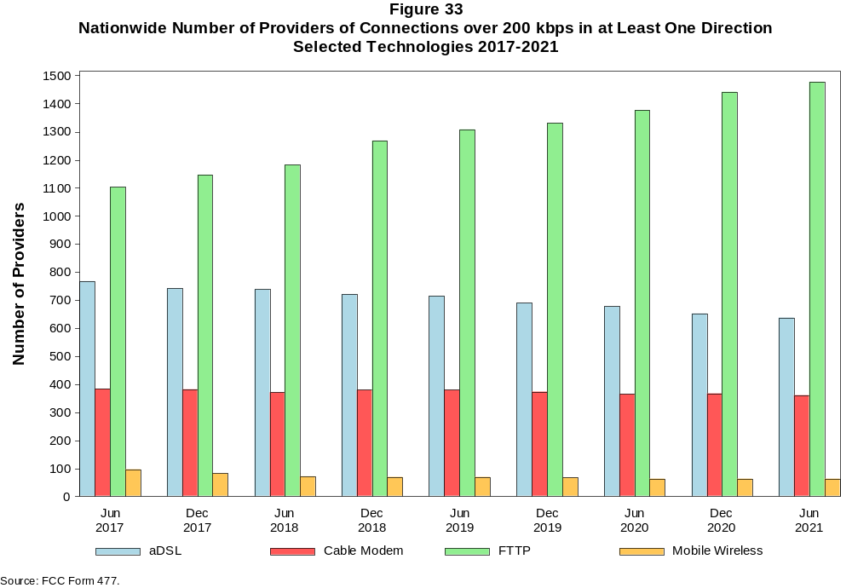

Figure 34
Residential Fixed Connections and Households by State as of June 30, 2021
(Connections and households, in thousands)

 |  | At least 200 kbps in  at least One Direction |  | At least 10 Mbps Down  and 1 Mbps Up |  | At least 25 Mbps Down  and 3 Mbps Up |  | At least 100 Mbps Down  and 20 Mbps Up |  | At least 940 Mbps Down  and 500 Mbps Up
State | Households | Connections | Subscribership  Ratio | Connections | Subscribership  Ratio | Connections | Subscribership  Ratio | Connections | Subscribership  Ratio | Connections | Subscribership  Ratio
Alabama | 1,903 | 1,577 | 0.83 | 1,429 | 0.75 | 1,267 | 0.67 | 433 | 0.23 | 112 | 0.06
Alaska | 261 | 232 | 0.89 | 213 | 0.82 | 158 | 0.61 | * | * | * | *
American Samoa | 10 | * | * | * | * | * | * | 0 | 0.00 | 0 | 0.00
Arizona | 2,684 | 2,465 | 0.92 | 2,323 | 0.87 | 2,113 | 0.79 | 475 | 0.18 | * | *
Arkansas | 1,158 | 925 | 0.80 | 806 | 0.70 | 683 | 0.59 | 254 | 0.22 | 53 | 0.05
California | 13,218 | 12,483 | 0.94 | 11,974 | 0.91 | 11,204 | 0.85 | 3,251 | 0.25 | 550 | 0.04
Colorado | 2,228 | 2,150 | 0.97 | 2,048 | 0.92 | 1,893 | 0.85 | 414 | 0.19 | 118 | 0.05
Connecticut | 1,397 | 1,332 | 0.95 | 1,279 | 0.92 | 1,141 | 0.82 | 377 | 0.27 | 28 | 0.02
Delaware | 381 | 391 | 1.03 | 383 | 1.01 | 381 | 1.00 | 129 | 0.34 | * | *
District of Columbia | 310 | 283 | 0.91 | 276 | 0.89 | 274 | 0.88 | 118 | 0.38 | * | *
Florida | 8,157 | 8,133 | 1.00 | 7,809 | 0.96 | 7,445 | 0.91 | 2,756 | 0.34 | 390 | 0.05
Georgia | 3,885 | 3,522 | 0.91 | 3,308 | 0.85 | 3,046 | 0.78 | 1,322 | 0.34 | 350 | 0.09
Guam | 42 | * | * | * | * | * | * | 0 | 0.00 | 0 | 0.00
Hawaii | 478 | 494 | 1.03 | 481 | 1.01 | * | * | * | * | * | *
Idaho | 657 | 597 | 0.91 | 529 | 0.80 | 411 | 0.62 | 176 | 0.27 | 23 | 0.04
Illinois | 4,930 | 4,238 | 0.86 | 4,015 | 0.81 | 3,690 | 0.75 | 1,386 | 0.28 | 129 | 0.03
Indiana | 2,623 | 2,245 | 0.86 | 2,064 | 0.79 | 1,875 | 0.71 | 718 | 0.27 | 125 | 0.05
Iowa | 1,276 | 1,075 | 0.84 | 966 | 0.76 | 839 | 0.66 | 317 | 0.25 | 32 | 0.03
Kansas | 1,140 | 988 | 0.87 | 914 | 0.80 | 812 | 0.71 | 301 | 0.26 | 111 | 0.10
Kentucky | 1,749 | 1,506 | 0.86 | 1,375 | 0.79 | 1,225 | 0.70 | 439 | 0.25 | 71 | 0.04
Louisiana | 1,749 | 1,453 | 0.83 | 1,337 | 0.76 | 1,185 | 0.68 | 381 | 0.22 | 75 | 0.04
Maine | 571 | 584 | 1.02 | 532 | 0.93 | 452 | 0.79 | 54 | 0.10 | 1 | 0.00
Maryland | 2,294 | 2,166 | 0.94 | 2,117 | 0.92 | 2,083 | 0.91 | 875 | 0.38 | * | *
Massachusetts | 2,714 | 2,556 | 0.94 | 2,498 | 0.92 | 2,476 | 0.91 | 731 | 0.27 | * | *
Michigan | 3,977 | 3,507 | 0.88 | 3,308 | 0.83 | 3,072 | 0.77 | 858 | 0.22 | 72 | 0.02
Minnesota | 2,229 | 1,999 | 0.90 | 1,855 | 0.83 | 1,673 | 0.75 | 378 | 0.17 | 54 | 0.02
Mississippi | 1,109 | 841 | 0.76 | 738 | 0.67 | 593 | 0.53 | 224 | 0.20 | 76 | 0.07
Missouri | 2,434 | 2,073 | 0.85 | 1,852 | 0.76 | 1,626 | 0.67 | 669 | 0.27 | 183 | 0.08
Montana | 436 | 394 | 0.90 | 349 | 0.80 | 295 | 0.68 | 50 | 0.11 | 7 | 0.02
Nebraska | 767 | 666 | 0.87 | 624 | 0.81 | 561 | 0.73 | 177 | 0.23 | 30 | 0.04

Figure 34 - Continued
Residential Fixed Connections and Households by State as of June 30, 2021
(Connections and households, in thousands)

 |  | At least 200 kbps in  at least One Direction |  | At least 10 Mbps Down  and 1 Mbps Up |  | At least 25 Mbps Down  and 3 Mbps Up |  | At least 100 Mbps Down  and 20 Mbps Up |  | At least 940 Mbps Down  and 500 Mbps Up
State | Households | Connections | Subscribership  Ratio | Connections | Subscribership  Ratio | Connections | Subscribership  Ratio | Connections | Subscribership  Ratio | Connections | Subscribership  Ratio
Nevada | 1,142 | 1,084 | 0.95 | 1,032 | 0.90 | 969 | 0.85 | 238 | 0.21 | 36 | 0.03
New Hampshire | 541 | 569 | 1.05 | 544 | 1.01 | 513 | 0.95 | 128 | 0.24 | 5 | 0.01
New Jersey | 3,397 | 3,214 | 0.95 | 3,161 | 0.93 | 3,123 | 0.92 | 1,843 | 0.54 | * | *
New Mexico | 798 | 697 | 0.87 | 609 | 0.76 | 514 | 0.64 | 80 | 0.10 | 7 | 0.01
New York | 7,530 | 6,766 | 0.90 | 6,649 | 0.88 | 6,380 | 0.85 | 3,662 | 0.49 | 930 | 0.12
North Carolina | 4,035 | 3,844 | 0.95 | 3,525 | 0.87 | 3,310 | 0.82 | 1,186 | 0.29 | 285 | 0.07
North Dakota | 317 | 281 | 0.89 | 273 | 0.86 | 261 | 0.83 | 127 | 0.40 | 5 | 0.01
Northern Mariana Isl | 16 | * | * | * | * | * | * | 0 | 0.00 | 0 | 0.00
Ohio | 4,754 | 4,208 | 0.89 | 3,941 | 0.83 | 3,543 | 0.75 | 898 | 0.19 | 86 | 0.02
Oklahoma | 1,504 | 1,201 | 0.80 | 1,088 | 0.72 | 955 | 0.63 | 323 | 0.21 | 84 | 0.06
Oregon | 1,658 | 1,539 | 0.93 | 1,436 | 0.87 | 1,329 | 0.80 | 287 | 0.17 | 63 | 0.04
Pennsylvania | 5,148 | 4,622 | 0.90 | 4,347 | 0.84 | 4,227 | 0.82 | 1,372 | 0.27 | * | *
Puerto Rico | 1,197 | 692 | 0.58 | 612 | 0.51 | 385 | 0.32 | 128 | 0.11 | 6 | 0.00
Rhode Island | 427 | 401 | 0.94 | 399 | 0.93 | 396 | 0.93 | 200 | 0.47 | * | *
South Carolina | 1,976 | 1,851 | 0.94 | 1,747 | 0.88 | 1,592 | 0.81 | 601 | 0.30 | 79 | 0.04
South Dakota | 346 | 306 | 0.88 | 298 | 0.86 | 282 | 0.81 | 96 | 0.28 | 1 | 0.00
Tennessee | 2,665 | 2,319 | 0.87 | 2,189 | 0.82 | 2,030 | 0.76 | 891 | 0.33 | 235 | 0.09
Texas | 10,239 | 9,179 | 0.90 | 8,773 | 0.86 | 8,031 | 0.78 | 3,490 | 0.34 | 967 | 0.09
Utah | 1,034 | 975 | 0.94 | 928 | 0.90 | 850 | 0.82 | 248 | 0.24 | 73 | 0.07
Vermont | 263 | 268 | 1.02 | 235 | 0.89 | 196 | 0.75 | 38 | 0.14 | 13 | 0.05
Virgin Islands | 43 | * | * | * | * | * | * | * | * | * | *
Virginia | 3,249 | 2,908 | 0.90 | 2,746 | 0.85 | 2,672 | 0.82 | 1,070 | 0.33 | * | *
Washington | 2,932 | 2,802 | 0.96 | 2,614 | 0.89 | 2,436 | 0.83 | 509 | 0.17 | 126 | 0.04
West Virginia | 711 | 562 | 0.79 | 462 | 0.65 | 392 | 0.55 | 130 | 0.18 | 2 | 0.00
Wisconsin | 2,402 | 2,123 | 0.88 | 1,941 | 0.81 | 1,710 | 0.71 | 359 | 0.15 | 48 | 0.02
Wyoming | 231 | 213 | 0.92 | 194 | 0.84 | 174 | 0.76 | 22 | 0.10 | 2 | 0.01
Total | 125,319 | 113,581 | 0.91 | 107,212 | 0.86 | 99,254 | 0.79 | 35,456 | 0.28 | 8,105 | 0.06

# = Rounds to Zero; * = Data withheld for confidentiality reasons.
Note: Numbers may not sum to totals due to rounding.
Sources: FCC Form 477 (Connections); 2017-2021 ACS 5-year estimates; Census 2010.

Figure 35
Connections by Type of End User by State as of June 30, 2021
(Connections over 200 kbps in at least one direction, in thousands)

 | Connections |  | Percentages
State | Residential | Business | Residential | Business | Total
Alabama | 5,784 | 1,434 | 80.1 | 19.9 | 7,218
Alaska | 890 | 143 | 86.2 | 13.8 | 1,033
American Samoa | * | * | * | * | *
Arizona | 8,856 | 1,551 | 85.1 | 14.9 | 10,407
Arkansas | 3,379 | 865 | 79.6 | 20.4 | 4,244
California | 51,430 | 9,805 | 84.0 | 16.0 | 61,234
Colorado | 7,181 | 1,533 | 82.4 | 17.6 | 8,715
Connecticut | 4,742 | 933 | 83.6 | 16.4 | 5,676
Delaware | 1,283 | 261 | 83.1 | 16.9 | 1,543
District of Columbia | 1,083 | 635 | 63.0 | 37.0 | 1,718
Florida | 28,632 | 4,973 | 85.2 | 14.8 | 33,605
Georgia | 13,137 | 3,075 | 81.0 | 19.0 | 16,211
Guam | * | * | * | * | *
Hawaii | 1,841 | 368 | 83.4 | 16.6 | 2,208
Idaho | 2,093 | 412 | 83.6 | 16.4 | 2,506
Illinois | 15,994 | 3,404 | 82.5 | 17.5 | 19,398
Indiana | 7,804 | 1,645 | 82.6 | 17.4 | 9,449
Iowa | 3,636 | 819 | 81.6 | 18.4 | 4,455
Kansas | 3,469 | 730 | 82.6 | 17.4 | 4,199
Kentucky | 5,146 | 955 | 84.3 | 15.7 | 6,101
Louisiana | 5,805 | 1,061 | 84.5 | 15.5 | 6,866
Maine | 1,545 | 466 | 76.8 | 23.2 | 2,011
Maryland | 7,986 | 1,436 | 84.8 | 15.2 | 9,421
Massachusetts | 8,823 | 1,830 | 82.8 | 17.2 | 10,653
Michigan | 12,233 | 2,513 | 83.0 | 17.0 | 14,746
Minnesota | 6,791 | 1,483 | 82.1 | 17.9 | 8,273
Mississippi | 3,494 | 682 | 83.7 | 16.3 | 4,176
Missouri | 7,356 | 1,504 | 83.0 | 17.0 | 8,860
Montana | 1,193 | 343 | 77.7 | 22.3 | 1,537
Nebraska | 2,204 | 603 | 78.5 | 21.5 | 2,807
Nevada | 4,042 | 602 | 87.0 | 13.0 | 4,644
New Hampshire | 1,654 | 428 | 79.4 | 20.6 | 2,082
New Jersey | 12,111 | 2,233 | 84.4 | 15.6 | 14,344
New Mexico | 2,571 | 486 | 84.1 | 15.9 | 3,056
New York | 25,886 | 5,776 | 81.8 | 18.2 | 31,662
North Carolina | 12,393 | 2,931 | 80.9 | 19.1 | 15,324
North Dakota | 883 | 238 | 78.8 | 21.2 | 1,121
Northern Mariana Isl | * | * | * | * | *
Ohio | 14,356 | 3,136 | 82.1 | 17.9 | 17,491
Oklahoma | 4,728 | 877 | 84.4 | 15.6 | 5,605
Oregon | 5,179 | 1,125 | 82.2 | 17.8 | 6,304
Pennsylvania | 15,601 | 3,432 | 82.0 | 18.0 | 19,033
Puerto Rico | 3,857 | 282 | 93.2 | 6.8 | 4,139
Rhode Island | 1,391 | 298 | 82.4 | 17.6 | 1,689
South Carolina | 6,016 | 1,366 | 81.5 | 18.5 | 7,382
South Dakota | 967 | 262 | 78.7 | 21.3 | 1,229
Tennessee | 8,161 | 1,937 | 80.8 | 19.2 | 10,098
Texas | 37,685 | 6,469 | 85.3 | 14.7 | 44,154
Utah | 3,599 | 791 | 82.0 | 18.0 | 4,391
Vermont | 715 | 240 | 74.9 | 25.1 | 955
Virgin Islands | 110 | 13 | 89.4 | 10.6 | 123
Virginia | 10,399 | 2,518 | 80.5 | 19.5 | 12,917
Washington | 9,573 | 1,948 | 83.1 | 16.9 | 11,521
West Virginia | 1,959 | 355 | 84.6 | 15.4 | 2,314
Wisconsin | 6,731 | 1,478 | 82.0 | 18.0 | 8,208
Wyoming | 681 | 181 | 79.0 | 21.0 | 862
Total | 415,260 | 85,000 | 83.0 | 17.0 | 500,261

# = Rounds to Zero.
* = Data withheld for confidentiality reasons.
Note: Numbers may not sum to totals due to rounding.
Source: FCC Form 477.

Figure 36
Connections by Technology by State as of June 30, 2021
(Connections over 200 kbps in at least one direction, in thousands)

State | ADSL | SDSL | Other  Wireline¹ | Cable  Modem | Fiber | Satellite | Fixed  Wireless | Mobile  Wireless | Total
Alabama | 382 | * | 4 | 981 | 270 | * | 15 | 5,504 | 7,218
Alaska | 66 | # | 8 | * | 14 | * | 19 | 763 | 1,033
American Samoa | 0 | 0 | 0 | * | * | 0 | * | * | *
Arizona | 547 | * | 11 | 1,757 | 201 | * | 80 | 7,769 | 10,407
Arkansas | 315 | * | 2 | 468 | 155 | * | 16 | 3,238 | 4,244
California | 2,117 | 4 | 79 | 9,459 | 1,622 | 129 | 227 | 47,598 | 61,234
Colorado | * | # | 17 | 1,567 | 226 | * | 104 | 6,386 | 8,715
Connecticut | * | * | 2 | 1,167 | 51 | * | * | 4,224 | 5,676
Delaware | * | * | * | 279 | * | * | 2 | * | 1,543
District of Columbia | * | * | 6 | * | * | * | 6 | 1,399 | 1,718
Florida | 1,122 | * | 19 | 6,182 | 1,364 | * | 42 | 24,795 | 33,605
Georgia | 768 | # | * | 2,253 | 722 | * | 23 | 12,368 | 16,211
Guam | * | 0 | * | * | * | 0 | * | * | *
Hawaii | * | * | 1 | * | 70 | * | 2 | 1,662 | 2,208
Idaho | 206 | # | * | 290 | 66 | * | 65 | 1,856 | 2,506
Illinois | 854 | 1 | 10 | 3,194 | 352 | 44 | 127 | 14,816 | 19,398
Indiana | 470 | # | 3 | 1,410 | 424 | 47 | 67 | 7,027 | 9,449
Iowa | 262 | # | * | 518 | 296 | * | 63 | 3,285 | 4,455
Kansas | 187 | # | * | 541 | 270 | * | 55 | 3,126 | 4,199
Kentucky | 334 | * | 2 | 915 | 315 | * | 27 | 4,472 | 6,101
Louisiana | 345 | * | 3 | 946 | 208 | * | 22 | 5,284 | 6,866
Maine | 105 | 1 | 3 | 490 | 23 | 11 | 9 | 1,368 | 2,011
Maryland | * | * | 16 | 1,333 | * | 16 | 12 | 7,083 | 9,421
Massachusetts | 70 | # | 17 | 2,105 | 570 | 6 | 23 | 7,862 | 10,653
Michigan | 635 | 1 | 5 | 2,768 | 206 | 85 | 77 | 10,968 | 14,746
Minnesota | 427 | 1 | * | 1,340 | 301 | * | 58 | 6,112 | 8,273
Mississippi | 309 | * | 9 | 402 | 129 | * | 18 | 3,243 | 4,176
Missouri | 525 | # | * | 1,137 | 432 | * | 69 | 6,619 | 8,860
Montana | 91 | * | 2 | 249 | 45 | * | 35 | 1,097 | 1,537
Nebraska | 125 | # | 2 | 402 | 145 | 9 | 44 | 2,080 | 2,807

Figure 36 - Continued
Connections by Technology by State as of June 30, 2021
(Connections over 200 kbps in at least one direction, in thousands)

State | ADSL | SDSL | Other  Wireline¹ | Cable  Modem | Fiber | Satellite | Fixed  Wireless | Mobile  Wireless | Total
Nevada | 154 | # | 5 | * | 108 | * | 42 | 3,473 | 4,644
New Hampshire | 54 | # | * | 515 | 45 | * | 4 | 1,455 | 2,082
New Jersey | 80 | * | 24 | 2,239 | * | 10 | 6 | 10,825 | 14,344
New Mexico | 219 | # | 4 | 424 | 53 | 19 | 38 | 2,300 | 3,056
New York | 205 | 1 | 36 | 5,116 | 1,994 | 44 | 24 | 24,243 | 31,662
North Carolina | 613 | # | 8 | 2,777 | 641 | 77 | 33 | 11,176 | 15,324
North Dakota | 27 | * | 1 | 172 | 110 | * | 4 | 804 | 1,121
Northern Mariana Isl | * | 0 | 0 | * | * | 0 | * | * | *
Ohio | 771 | * | 8 | 3,156 | 453 | * | 85 | 12,970 | 17,491
Oklahoma | 317 | # | 2 | 667 | 232 | 50 | 63 | 4,275 | 5,605
Oregon | 208 | # | 14 | 1,141 | 241 | 31 | 41 | 4,628 | 6,304
Pennsylvania | 391 | # | 24 | 3,407 | 1,110 | 40 | 33 | 14,027 | 19,033
Puerto Rico | * | 0 | 2 | * | 80 | * | 55 | 3,389 | 4,139
Rhode Island | * | * | * | * | * | * | 1 | * | 1,689
South Carolina | 339 | * | 3 | 1,273 | 331 | * | 14 | 5,385 | 7,382
South Dakota | 34 | * | # | 200 | 86 | * | 12 | 891 | 1,229
Tennessee | 375 | # | 4 | 1,437 | 617 | 56 | 27 | 7,582 | 10,098
Texas | 1,569 | 1 | * | 5,620 | 2,193 | * | 355 | 34,188 | 44,154
Utah | 151 | # | 7 | 614 | 209 | 7 | 75 | 3,328 | 4,391
Vermont | 77 | * | 3 | 176 | 37 | * | 4 | 653 | 955
Virgin Islands | * | 0 | 0 | * | * | * | * | 87 | 123
Virginia | 206 | # | 20 | 1,747 | 1,071 | 80 | 40 | 9,753 | 12,917
Washington | 389 | # | 47 | 2,188 | 282 | 46 | 61 | 8,507 | 11,521
West Virginia | * | * | 1 | 394 | 16 | 30 | 9 | 1,701 | 2,314
Wisconsin | 488 | * | 3 | * | 239 | * | 59 | 5,912 | 8,208
Wyoming | 42 | * | 1 | 130 | 17 | * | 39 | 625 | 862
Total | 18,085 | 18 | 517 | 79,330 | 21,120 | 1,910 | 2,445 | 376,835 | 500,261

¹ PowerLine and Other are summarized with Other Wireline for confidentiality reasons. See Technical Notes at the end of the report for a description of FCC Form 477 technology categories and
other reporting requirements.
# = Rounds to Zero.
* = Data withheld for confidentiality reasons.
Note: Numbers may not sum to totals due to rounding.
Source: FCC Form 477.

Figure 37
Percentage of Fixed Connections by Downstream Speed by State as of June 30, 2021

 | Over 200 kbps Upstream and
State | % over 200 kbps  Downstream | % at least 10 Mbps  Downstream | % at least 25 Mbps  Downstream | % at least 100 Mbps  Downstream | % at least 940 Mbps  Downstream
Alabama | 99.8 | 91.8 | 81.5 | 62.6 | 8.8
Alaska | 99.8 | 89.5 | 67.9 | * | *
American Samoa | * | * | * | * | *
Arizona | 99.8 | 94.6 | 86.3 | 60.2 | 11.6
Arkansas | 99.8 | 89.4 | 74.5 | 44.3 | 9.5
California | 99.8 | 95.1 | 88.6 | 70.5 | 10.0
Colorado | 99.9 | 95.7 | 88.2 | 66.4 | 14.9
Connecticut | 99.7 | 95.2 | 86.2 | 74.2 | 7.9
Delaware | 99.9 | 97.4 | 96.7 | 81.6 | 21.8
District of Columbia | 100.0 | 95.6 | 94.4 | 78.8 | 22.7
Florida | 99.8 | 96.7 | 91.6 | 71.4 | 7.9
Georgia | 99.6 | 93.7 | 86.4 | 65.5 | 13.8
Guam | * | * | * | * | *
Hawaii | 100.0 | 96.1 | * | * | *
Idaho | 99.9 | 90.0 | 70.2 | 49.9 | 6.7
Illinois | 99.8 | 94.4 | 86.7 | 64.2 | 8.4
Indiana | 99.6 | 92.5 | 83.3 | 60.1 | 8.6
Iowa | 99.4 | 91.2 | 79.1 | 54.1 | 9.7
Kansas | 99.8 | 93.1 | 81.5 | 55.6 | 14.3
Kentucky | 99.6 | 91.3 | 81.9 | 62.6 | 5.8
Louisiana | 99.8 | 92.4 | 82.0 | 56.3 | 9.9
Maine | 99.2 | 89.5 | 78.2 | 66.1 | 2.0
Maryland | 99.9 | 96.9 | 95.2 | 79.2 | 24.3
Massachusetts | 100.0 | 97.1 | 96.0 | 84.8 | 17.9
Michigan | 99.5 | 94.0 | 87.2 | 66.5 | 5.4
Minnesota | 99.8 | 93.8 | 84.5 | 62.1 | 7.9
Mississippi | 99.7 | 87.9 | 71.5 | 44.2 | 12.1
Missouri | 99.6 | 91.5 | 79.3 | 61.6 | 10.9
Montana | 99.9 | 90.7 | 76.0 | 55.9 | 2.3
Nebraska | 99.6 | 94.0 | 84.4 | 61.3 | 8.2

Figure 37 - Continued
Percentage of Fixed Connections by Downstream Speed by State as of June 30, 2021

 | Over 200 kbps Upstream and
State | % over 200 kbps  Downstream | % at least 10 Mbps  Downstream | % at least 25 Mbps  Downstream | % at least 100 Mbps  Downstream | % at least 940 Mbps  Downstream
Nevada | 100.0 | 96.2 | 90.2 | 66.6 | 12.4
New Hampshire | 99.5 | 93.9 | 89.6 | 79.6 | 9.9
New Jersey | 99.8 | 97.8 | 96.3 | 85.5 | 22.4
New Mexico | 99.9 | 89.2 | 75.3 | 48.2 | 5.8
New York | 99.8 | 97.5 | 93.5 | 83.9 | 13.9
North Carolina | 99.4 | 93.4 | 86.1 | 72.8 | 8.1
North Dakota | 99.9 | 97.2 | 91.8 | 73.3 | 6.4
Northern Mariana Isl | * | * | * | * | *
Ohio | 99.8 | 94.0 | 84.0 | 67.5 | 3.7
Oklahoma | 99.6 | 90.7 | 78.7 | 54.2 | 12.6
Oregon | 99.9 | 94.1 | 86.4 | 66.9 | 11.1
Pennsylvania | 99.8 | 94.3 | 91.2 | 73.1 | 15.7
Puerto Rico | 100.0 | 87.1 | 57.9 | 27.1 | 1.1
Rhode Island | 99.6 | 98.6 | 97.7 | 81.8 | 26.6
South Carolina | 99.8 | 94.6 | 86.0 | 70.7 | 5.8
South Dakota | 99.8 | 97.6 | 92.3 | 64.6 | 5.6
Tennessee | 99.7 | 94.4 | 87.5 | 68.0 | 13.0
Texas | 99.9 | 95.6 | 87.2 | 67.8 | 14.5
Utah | 100.0 | 95.4 | 86.9 | 65.5 | 15.4
Vermont | 99.4 | 85.5 | 74.7 | 60.8 | 9.6
Virgin Islands | * | * | * | * | *
Virginia | 99.5 | 94.5 | 90.8 | 73.8 | 21.9
Washington | 99.8 | 94.2 | 87.0 | 69.7 | 14.3
West Virginia | 97.8 | 81.6 | 69.7 | 53.1 | 6.6
Wisconsin | 99.2 | 92.8 | 80.9 | 64.3 | 2.9
Wyoming | 99.9 | 92.3 | 82.6 | 55.1 | 1.5
Total | 99.7 | 94.5 | 87.2 | 68.7 | 11.4

Source: FCC Form 477.

Figure 38
Providers of Connections by Technology by State as of June 30, 2021
(Connections over 200 kbps in at least one direction, in thousands)

State | ADSL | SDSL | Other  Wireline¹ | Cable  Modem | Fiber | Satellite | Fixed  Wireless | Mobile  Wireless | Total
Alabama | 24 | * | 14 | 19 | 48 | * | 31 | 6 | 87
Alaska | 16 | 4 | 8 | * | 19 | * | 18 | 10 | 40
American Samoa | 0 | 0 | 0 | * | * | 0 | * | * | *
Arizona | 21 | * | 18 | 16 | 51 | * | 56 | 6 | 104
Arkansas | 23 | * | 11 | 16 | 56 | * | 35 | 5 | 93
California | 31 | 14 | 43 | 34 | 93 | 4 | 135 | 5 | 223
Colorado | * | 7 | 19 | 17 | 81 | * | 75 | 9 | 144
Connecticut | * | * | 10 | 10 | 24 | * | * | 4 | 37
Delaware | * | * | * | 5 | * | * | 5 | * | 32
District of Columbia | * | * | 12 | * | * | * | 10 | 4 | 40
Florida | 17 | * | 26 | 19 | 80 | * | 46 | 6 | 126
Georgia | 26 | 4 | * | 27 | 92 | * | 32 | 5 | 123
Guam | * | 0 | * | * | * | 0 | * | * | *
Hawaii | * | * | 9 | * | 12 | * | 9 | 5 | 25
Idaho | 24 | 4 | * | 18 | 42 | * | 42 | 8 | 75
Illinois | 49 | 7 | 33 | 22 | 103 | 4 | 98 | 6 | 184
Indiana | 36 | 4 | 24 | 15 | 84 | 4 | 74 | 4 | 135
Iowa | 67 | 12 | * | 41 | 185 | * | 92 | 5 | 238
Kansas | 28 | 6 | * | 24 | 76 | * | 79 | 9 | 136
Kentucky | 17 | * | 13 | 29 | 61 | * | 33 | 7 | 109
Louisiana | 13 | * | 16 | 16 | 40 | * | 28 | 6 | 77
Maine | 12 | 6 | 10 | 8 | 22 | 4 | 19 | 4 | 46
Maryland | * | * | 16 | 17 | * | 4 | 28 | 5 | 81
Massachusetts | 8 | 4 | 16 | 13 | 39 | 4 | 21 | 4 | 64
Michigan | 28 | 6 | 24 | 27 | 83 | 4 | 68 | 7 | 141
Minnesota | 37 | 7 | * | 22 | 93 | * | 66 | 5 | 138
Mississippi | 14 | * | 11 | 12 | 42 | * | 18 | 5 | 72
Missouri | 31 | 5 | * | 19 | 84 | * | 86 | 7 | 153
Montana | 18 | * | 12 | 8 | 40 | * | 40 | 6 | 70
Nebraska | 26 | 5 | 11 | 21 | 62 | 4 | 55 | 6 | 102

Figure 38 - Continued
Providers of Connections by Technology by State as of June 30, 2021
(Connections over 200 kbps in at least one direction, in thousands)

State | ADSL | SDSL | Other  Wireline¹ | Cable  Modem | Fiber | Satellite | Fixed  Wireless | Mobile  Wireless | Total
Nevada | 17 | 5 | 14 | * | 46 | * | 36 | 5 | 82
New Hampshire | 9 | 4 | * | 6 | 25 | * | 11 | 4 | 39
New Jersey | 10 | * | 22 | 10 | * | 4 | 12 | 4 | 65
New Mexico | 19 | 4 | 12 | 11 | 40 | 4 | 44 | 6 | 75
New York | 29 | 4 | 27 | 22 | 83 | 4 | 32 | 4 | 119
North Carolina | 21 | 4 | 20 | 26 | 64 | 4 | 36 | 6 | 103
North Dakota | 18 | * | 9 | 9 | 36 | * | 14 | 6 | 53
Northern Mariana Isl | * | 0 | 0 | * | * | 0 | * | * | *
Ohio | 35 | * | 24 | 34 | 92 | * | 76 | 4 | 169
Oklahoma | 33 | 4 | 13 | 13 | 62 | 4 | 56 | 9 | 114
Oregon | 33 | 5 | 21 | 17 | 68 | 4 | 55 | 5 | 114
Pennsylvania | 22 | 5 | 23 | 28 | 71 | 4 | 44 | 7 | 135
Puerto Rico | * | 0 | 4 | * | 16 | * | 30 | 4 | 39
Rhode Island | * | * | * | * | * | * | 5 | * | 27
South Carolina | 18 | * | 14 | 16 | 44 | * | 19 | 6 | 67
South Dakota | 18 | * | 11 | 9 | 47 | * | 30 | 6 | 81
Tennessee | 20 | 4 | 20 | 20 | 80 | 4 | 39 | 6 | 122
Texas | 64 | 7 | * | 31 | 145 | * | 181 | 10 | 283
Utah | 21 | 4 | 17 | 12 | 40 | 4 | 40 | 8 | 74
Vermont | 8 | * | 8 | 4 | 23 | * | 12 | 5 | 37
Virgin Islands | * | 0 | 0 | * | * | * | * | 4 | 6
Virginia | 20 | 5 | 22 | 19 | 84 | 4 | 47 | 6 | 123
Washington | 23 | 5 | 30 | 27 | 80 | 4 | 59 | 6 | 123
West Virginia | * | * | 9 | 17 | 33 | 4 | 23 | 6 | 70
Wisconsin | 39 | * | 21 | * | 81 | * | 58 | 6 | 122
Wyoming | 14 | * | 8 | 7 | 27 | * | 24 | 8 | 52
Total | 638 | 102 | 203 | 362 | 1,477 | 6 | 1,383 | 63 | 2,392

¹ Power Line and Other are summarized with Other Wireline for confidentiality reasons. See Technical Notes at the end of the report for a description of FCC Form 477 technology categories and
other reporting requirements.
# = Rounds to Zero.
* = Data withheld for confidentiality reasons.
Note: Numbers may not sum to totals due to rounding.
Source: FCC Form 477.

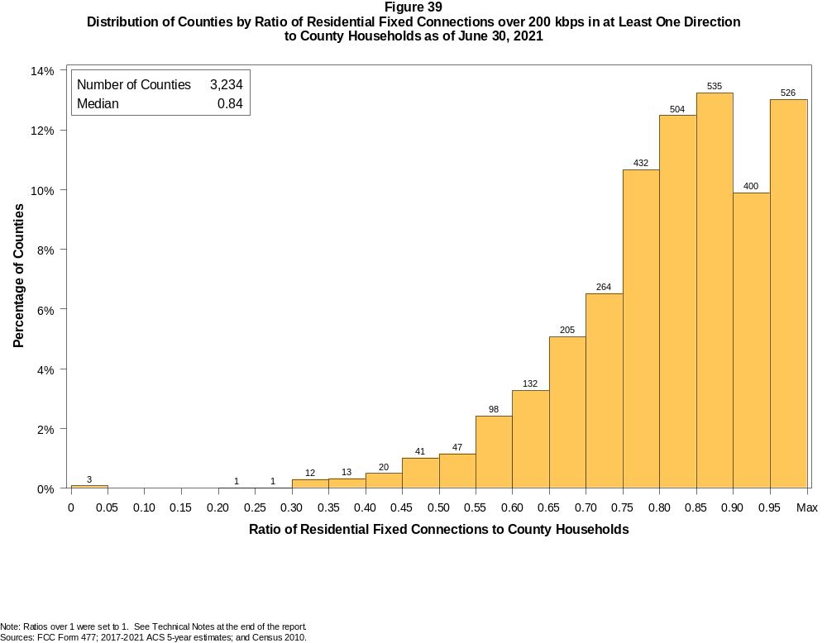

Figure 40
Distribution of Counties by Ratio of Residential Fixed Connections over 200 kbps in at Least One Direction
to County Households by Technology as of June 30, 2021

 | Ratio of Residential Fixed Connections to County Households
Technology | Zero | Greater than 0 and no more than 5% | Greater than 5 and no more than 10% | Greater than 10 and no more than 20% | Greater than 20 and no more than 30% | Greater than 30 and no more than 40% | Greater than 40 and no more than 50% | Greater than 50 and no more than 60% | Greater than 60 and no more than 80% | Greater than 80 and no more than 100% | 100% or more
aDSL | 2.0 | 10.5 | 13.0 | 29.9 | 21.0 | 12.2 | 5.8 | 3.1 | 2.0 | 0.4 | 0.3
sDSL | 94.7 | 5.3 | 0.0 | 0.0 | 0.0 | 0.0 | 0.0 | 0.0 | 0.0 | 0.0 | 0.0
Other Wireline¹ | 94.4 | 5.5 | 0.0 | 0.0 | 0.0 | 0.0 | 0.0 | 0.0 | 0.0 | 0.0 | 0.0
Cable Modem | 11.1 | 5.4 | 5.0 | 10.6 | 12.4 | 10.9 | 11.8 | 11.4 | 16.9 | 3.5 | 1.0
FTTP | 8.1 | 38.4 | 13.4 | 15.0 | 7.8 | 5.1 | 3.8 | 2.6 | 3.6 | 1.9 | 0.2
Satellite | 0.4 | 65.0 | 21.4 | 11.0 | 1.6 | 0.4 | 0.1 | 0.1 | 0.0 | 0.0 | 0.0
Fixed Wireless | 2.8 | 63.8 | 15.8 | 10.8 | 3.9 | 1.8 | 0.5 | 0.2 | 0.2 | 0.0 | 0.1
Total | 0.1 | 0.0 | 0.0 | 0.0 | 0.1 | 0.8 | 1.9 | 4.5 | 31.9 | 51.6 | 9.2

¹ Power Line and Other are summarized with Other Wireline. See Technical Notes at the end of the report for a description of FCC Form 477 technology categories and other reporting requirements.
Note: Numbers may not sum to totals due to rounding.
Sources: FCC Form 477; 2017-2021 ACS 5-year estimates; and Census 2010.

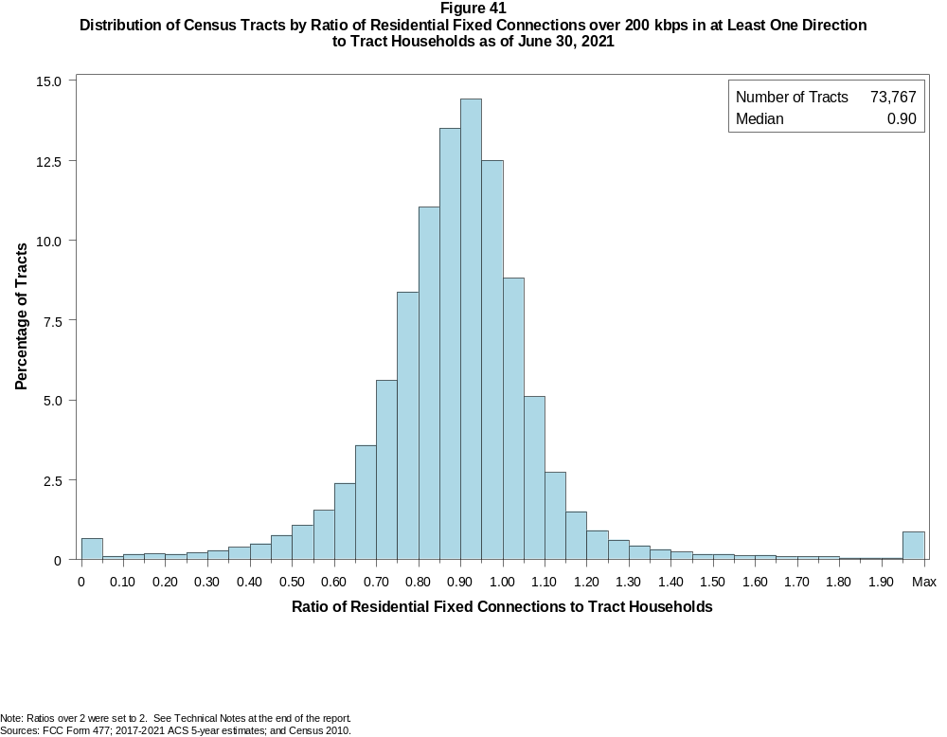

Figure 42
Distribution of Census Tracts by Ratio of Residential Fixed Connections over 200 kbps in at Least One Direction
to Tract Households by Technology as of June 30, 2021

 | Ratio of Residential Fixed Connections to Tract Households
Technology | Zero | Greater than 0 and no more than 5% | Greater than 5 and no more than 10% | Greater than 10 and no more than 20% | Greater than 20 and no more than 30% | Greater than 30 and no more than 40% | Greater than 40 and no more than 50% | Greater than 50 and no more than 60% | Greater than 60 and no more than 80% | Greater than 80 and no more than 100% | 100% or more
aDSL | 5.6 | 29.5 | 16.3 | 24.6 | 13.7 | 5.1 | 2.4 | 1.3 | 1.0 | 0.2 | 0.2
sDSL | 99.3 | 0.6 | 0.0 | 0.0 | 0.0 | 0.0 | 0.0 | 0.0 | 0.0 | 0.0 | 0.0
Other Wireline¹ | 99.1 | 0.8 | 0.1 | 0.0 | 0.0 | 0.0 | 0.0 | 0.0 | 0.0 | 0.0 | 0.0
Cable Modem | 4.2 | 2.6 | 1.4 | 3.1 | 4.1 | 6.9 | 11.6 | 16.1 | 32.8 | 13.6 | 3.4
FTTP | 26.4 | 24.3 | 8.5 | 11.9 | 8.9 | 6.9 | 5.4 | 3.5 | 3.2 | 0.8 | 0.3
Satellite | 29.4 | 60.6 | 5.3 | 3.5 | 0.8 | 0.2 | 0.1 | 0.0 | 0.0 | 0.0 | 0.0
Fixed Wireless | 13.7 | 76.9 | 3.8 | 3.1 | 1.2 | 0.6 | 0.3 | 0.2 | 0.1 | 0.0 | 0.1
Total | 0.6 | 0.1 | 0.1 | 0.4 | 0.4 | 0.7 | 1.3 | 2.6 | 20.0 | 51.5 | 22.5

¹ Power Line and Other are summarized with Other Wireline. See Technical Notes at the end of the report for a description of FCC Form 477 technology categories and other reporting requirements.
Note: Numbers may not sum to totals due to rounding.
Sources: FCC Form 477; 2017-2021 ACS 5-year estimates; and Census 2010.

Figure 43
Percentage of Developed Census Blocks with Residential Fixed Service by Technology as of June 30, 2021
(Internet Access Service over 200 kbps in at least one direction)

 | Number of Providers
Technology | Zero | One | Two | Three | Four | Five | Six | Seven or More
aDSL | 24.1 | 74.0 | 1.8 | 0.0 | 0.0 | 0.0 | 0.0 | 0.0
sDSL | 99.6 | 0.4 | 0.0 | 0.0 | 0.0 | 0.0 | 0.0 | 0.0
Other Wireline¹ | 99.6 | 0.3 | 0.0 | 0.0 | 0.0 | 0.0 | 0.0 | 0.0
Cable Modem | 32.7 | 63.0 | 4.2 | 0.1 | 0.0 | 0.0 | 0.0 | 0.0
FTTP | 67.7 | 29.0 | 3.2 | 0.1 | 0.0 | 0.0 | 0.0 | 0.0
Satellite | 0.0 | 0.1 | 1.0 | 78.2 | 20.6 | 0.0 | 0.0 | 0.0
Fixed Wireless | 26.7 | 34.7 | 20.6 | 11.3 | 4.7 | 1.5 | 0.4 | 0.1
aDSL and/or Cable Modem and/or FTTP | 9.4 | 24.2 | 56.1 | 9.6 | 0.6 | 0.1 | 0.0 | 0.0
Any Technology | 0.0 | 0.1 | 0.0 | 2.6 | 9.7 | 21.1 | 27.1 | 39.3

¹ Power Line and Other are summarized with Other Wireline. See Technical Notes at the end of the report for a description of FCC Form 477 technology categories and other reporting requirements.
Note: Numbers may not sum to totals due to rounding. The number of providers in a census block does not necessarily reflect the number of choices available to a particular household, and does not
purport to measure competition. Providers may list a census block on FCC Form 477 if service can be provided to at least one location in the block. Developed census blocks are those with housing units
based on the 2010 census.
Sources: FCC Form 477 and Census 2010.

Figure 44
Distribution of Counties by Ratio of Residential Fixed Connections to County Households by State as of June 30, 2021
(Connections over 200 kbps in at least one direction)

 |  | Ratio of Residential Fixed Connections over 200 kbps in at Least One Direction to County Households
State | Counties | Zero | Greater than 0 and no more than 5% | Greater than 5 and no more than 10% | Greater than 10 and no more than 20% | Greater than 20 and no more than 30% | Greater than 30 and no more than 40% | Greater than 40 and no more than 50% | Greater than 50 and no more than 60% | Greater than 60 and no more than 80% | Greater than 80 and no more than 100% | 100% or more
Alabama | 67 | 0 | 0 | 0 | 0 | 0 | 0 | 0 | 8 | 33 | 26 | 0
Alaska | 29 | 0 | 0 | 0 | 0 | 1 | 0 | 1 | 2 | 4 | 14 | 7
American Samoa | 5 | 2 | 0 | 0 | 0 | 0 | 0 | 2 | 0 | 1 | 0 | 0
Arizona | 15 | 0 | 0 | 0 | 0 | 0 | 0 | 0 | 0 | 3 | 11 | 1
Arkansas | 75 | 0 | 0 | 0 | 0 | 0 | 0 | 2 | 8 | 48 | 16 | 1
California | 58 | 0 | 0 | 0 | 0 | 0 | 0 | 1 | 0 | 2 | 48 | 7
Colorado | 64 | 0 | 0 | 0 | 0 | 0 | 1 | 2 | 1 | 14 | 28 | 18
Connecticut | 8 | 0 | 0 | 0 | 0 | 0 | 0 | 0 | 0 | 0 | 8 | 0
Delaware | 3 | 0 | 0 | 0 | 0 | 0 | 0 | 0 | 0 | 0 | 2 | 1
District of Columbia | 1 | 0 | 0 | 0 | 0 | 0 | 0 | 0 | 0 | 0 | 1 | 0
Florida | 67 | 0 | 0 | 0 | 0 | 0 | 0 | 1 | 1 | 14 | 28 | 23
Georgia | 159 | 0 | 0 | 0 | 0 | 0 | 1 | 4 | 11 | 66 | 63 | 14
Guam | 1 | 0 | 0 | 0 | 0 | 0 | 0 | 0 | 0 | 0 | 1 | 0
Hawaii | 5 | 0 | 0 | 0 | 0 | 0 | 0 | 0 | 0 | 0 | 2 | 3
Idaho | 44 | 0 | 0 | 0 | 0 | 0 | 0 | 1 | 2 | 13 | 19 | 9
Illinois | 102 | 0 | 0 | 0 | 0 | 0 | 0 | 2 | 6 | 52 | 41 | 1
Indiana | 92 | 0 | 0 | 0 | 0 | 0 | 0 | 0 | 1 | 45 | 46 | 0
Iowa | 99 | 0 | 0 | 0 | 0 | 0 | 0 | 0 | 0 | 38 | 60 | 1
Kansas | 105 | 0 | 0 | 0 | 0 | 0 | 0 | 0 | 2 | 47 | 53 | 3
Kentucky | 120 | 0 | 0 | 0 | 0 | 0 | 0 | 0 | 7 | 44 | 68 | 1
Louisiana | 64 | 0 | 0 | 0 | 0 | 0 | 2 | 3 | 6 | 32 | 21 | 0
Maine | 16 | 0 | 0 | 0 | 0 | 0 | 0 | 0 | 0 | 0 | 7 | 9
Maryland | 24 | 0 | 0 | 0 | 0 | 0 | 0 | 0 | 0 | 3 | 20 | 1
Massachusetts | 14 | 0 | 0 | 0 | 0 | 0 | 0 | 0 | 0 | 0 | 11 | 3
Michigan | 83 | 0 | 0 | 0 | 0 | 0 | 0 | 1 | 0 | 18 | 52 | 12
Minnesota | 87 | 0 | 0 | 0 | 0 | 0 | 0 | 1 | 0 | 10 | 68 | 8
Mississippi | 82 | 0 | 0 | 0 | 0 | 0 | 1 | 4 | 22 | 44 | 10 | 1
Missouri | 115 | 0 | 0 | 0 | 0 | 0 | 0 | 4 | 5 | 47 | 54 | 5
Montana | 56 | 0 | 0 | 0 | 0 | 0 | 0 | 0 | 0 | 14 | 34 | 8
Nebraska | 93 | 0 | 0 | 0 | 0 | 0 | 0 | 1 | 2 | 41 | 47 | 2

Figure 44 - Continued
Distribution of Counties by Ratio of Residential Fixed Connections to County Households by State as of June 30, 2021
(Connections over 200 kbps in at least one direction)

 |  | Ratio of Residential Fixed Connections over 200 kbps in at Least One Direction to County Households
State | Counties | Zero | Greater than 0 and no more than 5% | Greater than 5 and no more than 10% | Greater than 10 and no more than 20% | Greater than 20 and no more than 30% | Greater than 30 and no more than 40% | Greater than 40 and no more than 50% | Greater than 50 and no more than 60% | Greater than 60 and no more than 80% | Greater than 80 and no more than 100% | 100% or more
Nevada | 17 | 0 | 0 | 0 | 0 | 0 | 0 | 2 | 1 | 3 | 10 | 1
New Hampshire | 10 | 0 | 0 | 0 | 0 | 0 | 0 | 0 | 0 | 0 | 5 | 5
New Jersey | 21 | 0 | 0 | 0 | 0 | 0 | 0 | 0 | 0 | 0 | 18 | 3
New Mexico | 33 | 0 | 0 | 0 | 0 | 0 | 0 | 1 | 0 | 10 | 16 | 6
New York | 62 | 0 | 0 | 0 | 0 | 0 | 0 | 1 | 0 | 4 | 47 | 10
North Carolina | 100 | 0 | 0 | 0 | 0 | 0 | 0 | 1 | 1 | 19 | 56 | 23
North Dakota | 53 | 0 | 0 | 0 | 0 | 0 | 0 | 0 | 0 | 5 | 41 | 7
Northern Mariana Isl | 4 | 1 | 0 | 0 | 0 | 0 | 1 | 0 | 2 | 0 | 0 | 0
Ohio | 88 | 0 | 0 | 0 | 0 | 0 | 0 | 1 | 1 | 22 | 63 | 1
Oklahoma | 77 | 0 | 0 | 0 | 0 | 0 | 0 | 4 | 9 | 46 | 18 | 0
Oregon | 36 | 0 | 0 | 0 | 0 | 0 | 0 | 0 | 1 | 9 | 22 | 4
Pennsylvania | 67 | 0 | 0 | 0 | 0 | 0 | 0 | 0 | 0 | 7 | 52 | 8
Puerto Rico | 78 | 0 | 0 | 0 | 0 | 1 | 15 | 17 | 19 | 24 | 2 | 0
Rhode Island | 5 | 0 | 0 | 0 | 0 | 0 | 0 | 0 | 0 | 0 | 3 | 2
South Carolina | 46 | 0 | 0 | 0 | 0 | 0 | 0 | 0 | 2 | 19 | 21 | 4
South Dakota | 66 | 0 | 0 | 0 | 0 | 0 | 1 | 0 | 0 | 13 | 51 | 1
Tennessee | 95 | 0 | 0 | 0 | 0 | 0 | 0 | 0 | 1 | 41 | 51 | 2
Texas | 254 | 0 | 0 | 0 | 0 | 0 | 1 | 0 | 15 | 96 | 118 | 24
Utah | 29 | 0 | 0 | 0 | 0 | 0 | 0 | 0 | 0 | 1 | 15 | 13
Vermont | 14 | 0 | 0 | 0 | 0 | 0 | 0 | 0 | 0 | 0 | 7 | 7
Virgin Islands | 3 | 0 | 0 | 0 | 0 | 0 | 0 | 0 | 0 | 2 | 1 | 0
Virginia | 134 | 0 | 0 | 0 | 0 | 0 | 1 | 4 | 6 | 42 | 72 | 9
Washington | 39 | 0 | 0 | 0 | 0 | 0 | 0 | 0 | 1 | 6 | 25 | 7
West Virginia | 55 | 0 | 0 | 0 | 0 | 0 | 1 | 0 | 1 | 21 | 28 | 4
Wisconsin | 72 | 0 | 0 | 0 | 0 | 0 | 0 | 0 | 0 | 8 | 52 | 12
Wyoming | 23 | 0 | 0 | 0 | 0 | 0 | 0 | 0 | 1 | 2 | 16 | 4
Total | 3,234 | 3 | 0 | 0 | 0 | 2 | 25 | 61 | 145 | 1033 | 1669 | 296

Note: Numbers may not sum to totals due to rounding. See Technical Notes at the end of the report.
Sources: FCC Form 477; 2017-2021 ACS 5-year estimates (Households for U.S. and District of Columbia); Census 2010 (Households for Puerto Rico, American Samoa,
Guam, Northern Mariana Islands and U.S. Virgin Islands).

Figure 45
Distribution of Census Tracts by Ratio of Residential Fixed Connections to Tract Households by State as of June 30, 2021
(Connections over 200 kbps in at least one direction)

 |  | Ratio of Residential Fixed Connections over 200 kbps in at Least One Direction to Tract Households
State | Tracts | Zero | Greater than 0 and no more than 5% | Greater than 5 and no more than 10% | Greater than 10 and no more than 20% | Greater than 20 and no more than 30% | Greater than 30 and no more than 40% | Greater than 40 and no more than 50% | Greater than 50 and no more than 60% | Greater than 60 and no more than 80% | Greater than 80 and no more than 100% | 100% or more
Alabama | 1,179 | 0 | 0 | 1 | 0 | 4 | 19 | 45 | 88 | 366 | 507 | 149
Alaska | 167 | 1 | 0 | 0 | 2 | 2 | 4 | 2 | 10 | 31 | 82 | 33
American Samoa | 18 | 2 | 0 | 0 | 0 | 0 | 3 | 6 | 4 | 1 | 1 | 1
Arizona | 1,526 | 9 | 1 | 3 | 6 | 7 | 16 | 16 | 41 | 298 | 696 | 433
Arkansas | 686 | 1 | 0 | 0 | 0 | 1 | 8 | 38 | 66 | 274 | 240 | 58
California | 8,036 | 48 | 12 | 1 | 10 | 12 | 21 | 45 | 76 | 804 | 4,759 | 2,248
Colorado | 1,249 | 9 | 0 | 0 | 2 | 1 | 3 | 8 | 19 | 138 | 687 | 382
Connecticut | 829 | 3 | 0 | 0 | 1 | 0 | 0 | 1 | 3 | 76 | 452 | 293
Delaware | 215 | 1 | 0 | 0 | 0 | 0 | 1 | 0 | 0 | 30 | 108 | 75
District of Columbia | 179 | 0 | 0 | 0 | 2 | 0 | 0 | 0 | 6 | 31 | 101 | 39
Florida | 4,199 | 30 | 3 | 3 | 3 | 6 | 9 | 20 | 73 | 529 | 1,759 | 1,764
Georgia | 1,964 | 6 | 0 | 2 | 1 | 5 | 13 | 28 | 77 | 458 | 901 | 473
Guam | 56 | 8 | 10 | 1 | 4 | 2 | 1 | 5 | 6 | 2 | 6 | 11
Hawaii | 326 | 9 | 1 | 0 | 2 | 0 | 2 | 2 | 2 | 32 | 137 | 139
Idaho | 298 | 0 | 0 | 0 | 0 | 2 | 2 | 3 | 14 | 68 | 149 | 60
Illinois | 3,121 | 4 | 0 | 0 | 4 | 5 | 16 | 42 | 98 | 871 | 1,712 | 369
Indiana | 1,508 | 5 | 1 | 0 | 4 | 0 | 7 | 18 | 56 | 438 | 780 | 199
Iowa | 825 | 3 | 0 | 0 | 0 | 1 | 1 | 6 | 17 | 310 | 429 | 58
Kansas | 770 | 6 | 0 | 1 | 1 | 4 | 3 | 7 | 25 | 223 | 387 | 113
Kentucky | 1,115 | 5 | 0 | 3 | 1 | 3 | 8 | 22 | 35 | 309 | 578 | 151
Louisiana | 1,136 | 8 | 1 | 1 | 6 | 3 | 13 | 40 | 81 | 366 | 457 | 160
Maine | 351 | 0 | 0 | 0 | 0 | 0 | 0 | 0 | 1 | 28 | 175 | 147
Maryland | 1,394 | 6 | 1 | 1 | 1 | 2 | 3 | 11 | 15 | 194 | 780 | 380
Massachusetts | 1,471 | 12 | 1 | 2 | 1 | 0 | 6 | 5 | 11 | 206 | 872 | 355
Michigan | 2,767 | 24 | 2 | 1 | 9 | 12 | 23 | 33 | 75 | 552 | 1,539 | 497
Minnesota | 1,335 | 4 | 0 | 0 | 0 | 0 | 4 | 4 | 15 | 278 | 820 | 210
Mississippi | 661 | 4 | 0 | 0 | 1 | 4 | 12 | 37 | 104 | 233 | 211 | 55
Missouri | 1,393 | 2 | 0 | 0 | 4 | 5 | 12 | 31 | 62 | 396 | 684 | 197
Montana | 271 | 1 | 0 | 0 | 0 | 0 | 1 | 1 | 5 | 64 | 149 | 50
Nebraska | 532 | 2 | 0 | 1 | 1 | 0 | 0 | 2 | 7 | 148 | 305 | 66

Figure 45 - Continued
Distribution of Census Tracts by Ratio of Residential Fixed Connections to Tract Households by State as of June 30, 2021
(Connections over 200 kbps in at least one direction)

 |  | Ratio of Residential Fixed Connections over 200 kbps in at Least One Direction to Tract Households
State | Tracts | Zero | Greater than 0 and no more than 5% | Greater than 5 and no more than 10% | Greater than 10 and no more than 20% | Greater than 20 and no more than 30% | Greater than 30 and no more than 40% | Greater than 40 and no more than 50% | Greater than 50 and no more than 60% | Greater than 60 and no more than 80% | Greater than 80 and no more than 100% | 100% or more
Nevada | 683 | 4 | 0 | 1 | 0 | 0 | 0 | 11 | 11 | 95 | 339 | 222
New Hampshire | 294 | 2 | 0 | 0 | 0 | 0 | 0 | 0 | 1 | 7 | 142 | 142
New Jersey | 2,004 | 9 | 1 | 0 | 2 | 3 | 6 | 9 | 13 | 249 | 1,135 | 577
New Mexico | 499 | 1 | 0 | 1 | 4 | 2 | 10 | 8 | 18 | 141 | 225 | 89
New York | 4,900 | 70 | 2 | 5 | 21 | 13 | 18 | 22 | 55 | 1,057 | 2,636 | 1,001
North Carolina | 2,183 | 15 | 1 | 0 | 1 | 4 | 9 | 17 | 29 | 361 | 1,037 | 709
North Dakota | 205 | 0 | 0 | 0 | 0 | 0 | 0 | 2 | 1 | 50 | 118 | 34
Northern Mariana Isl | 22 | 2 | 0 | 0 | 0 | 1 | 6 | 4 | 2 | 3 | 3 | 1
Ohio | 2,946 | 5 | 0 | 0 | 5 | 4 | 14 | 25 | 59 | 653 | 1,783 | 398
Oklahoma | 1,046 | 0 | 3 | 1 | 3 | 9 | 20 | 48 | 87 | 369 | 395 | 111
Oregon | 827 | 2 | 1 | 0 | 0 | 2 | 0 | 7 | 6 | 102 | 511 | 196
Pennsylvania | 3,217 | 18 | 2 | 3 | 4 | 4 | 8 | 14 | 45 | 610 | 1,962 | 547
Puerto Rico | 903 | 14 | 8 | 38 | 133 | 123 | 126 | 116 | 82 | 81 | 49 | 133
Rhode Island | 241 | 0 | 0 | 1 | 0 | 0 | 0 | 1 | 2 | 23 | 151 | 63
South Carolina | 1,097 | 9 | 0 | 0 | 1 | 6 | 7 | 14 | 51 | 271 | 437 | 301
South Dakota | 222 | 0 | 0 | 0 | 2 | 0 | 0 | 2 | 4 | 54 | 134 | 26
Tennessee | 1,497 | 12 | 1 | 0 | 1 | 2 | 9 | 26 | 39 | 432 | 751 | 224
Texas | 5,253 | 31 | 3 | 1 | 7 | 11 | 24 | 68 | 207 | 1,350 | 2,359 | 1,192
Utah | 588 | 1 | 2 | 0 | 1 | 1 | 1 | 5 | 6 | 74 | 301 | 196
Vermont | 184 | 1 | 0 | 0 | 0 | 0 | 0 | 1 | 2 | 4 | 99 | 77
Virgin Islands | 29 | 0 | 0 | 0 | 1 | 0 | 3 | 1 | 4 | 12 | 5 | 3
Virginia | 1,895 | 17 | 3 | 1 | 2 | 6 | 18 | 34 | 56 | 358 | 992 | 408
Washington | 1,446 | 2 | 0 | 1 | 1 | 2 | 2 | 4 | 8 | 114 | 858 | 454
West Virginia | 484 | 0 | 1 | 3 | 4 | 10 | 5 | 13 | 31 | 163 | 182 | 72
Wisconsin | 1,393 | 3 | 1 | 0 | 1 | 1 | 2 | 5 | 10 | 339 | 825 | 206
Wyoming | 132 | 1 | 0 | 1 | 0 | 0 | 0 | 1 | 2 | 18 | 80 | 29
Total | 73,767 | 432 | 62 | 78 | 260 | 285 | 499 | 936 | 1,923 | 14,744 | 37,972 | 16,576

Note: Numbers may not sum to totals due to rounding. See Technical Notes at the end of the report.
Sources: FCC Form 477; 2017-2021 ACS 5-year estimates (Households for U.S. and District of Columbia); Census 2010 (Households for Puerto Rico, American Samoa,
Guam, Northern Mariana Islands and U.S. Virgin Islands).

